# Accessing the Website

Click the compressed package, unzip it, click the WebApplicationnew.sln file, open the file, click the button, you can access the website.

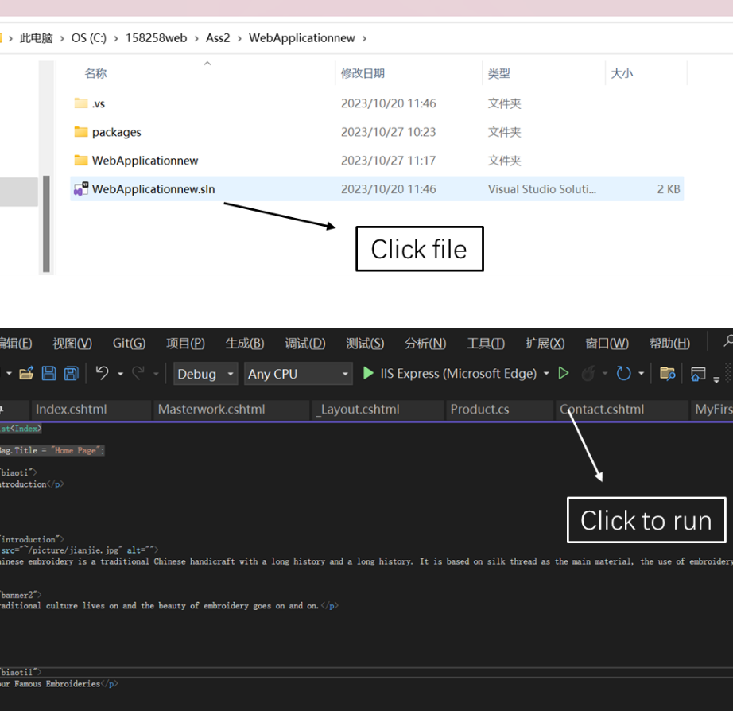

# Website Layout

The website is mainly divided into six sections, namely Home, History, Masterwork, Category, Merchandises and Contact us, all of which use fixed layout.

## Home

This page gives a brief introduction to Chinese embroidery and the four famous embroideries, showing the characteristics of embroidery with a long history, exquisite and significant.

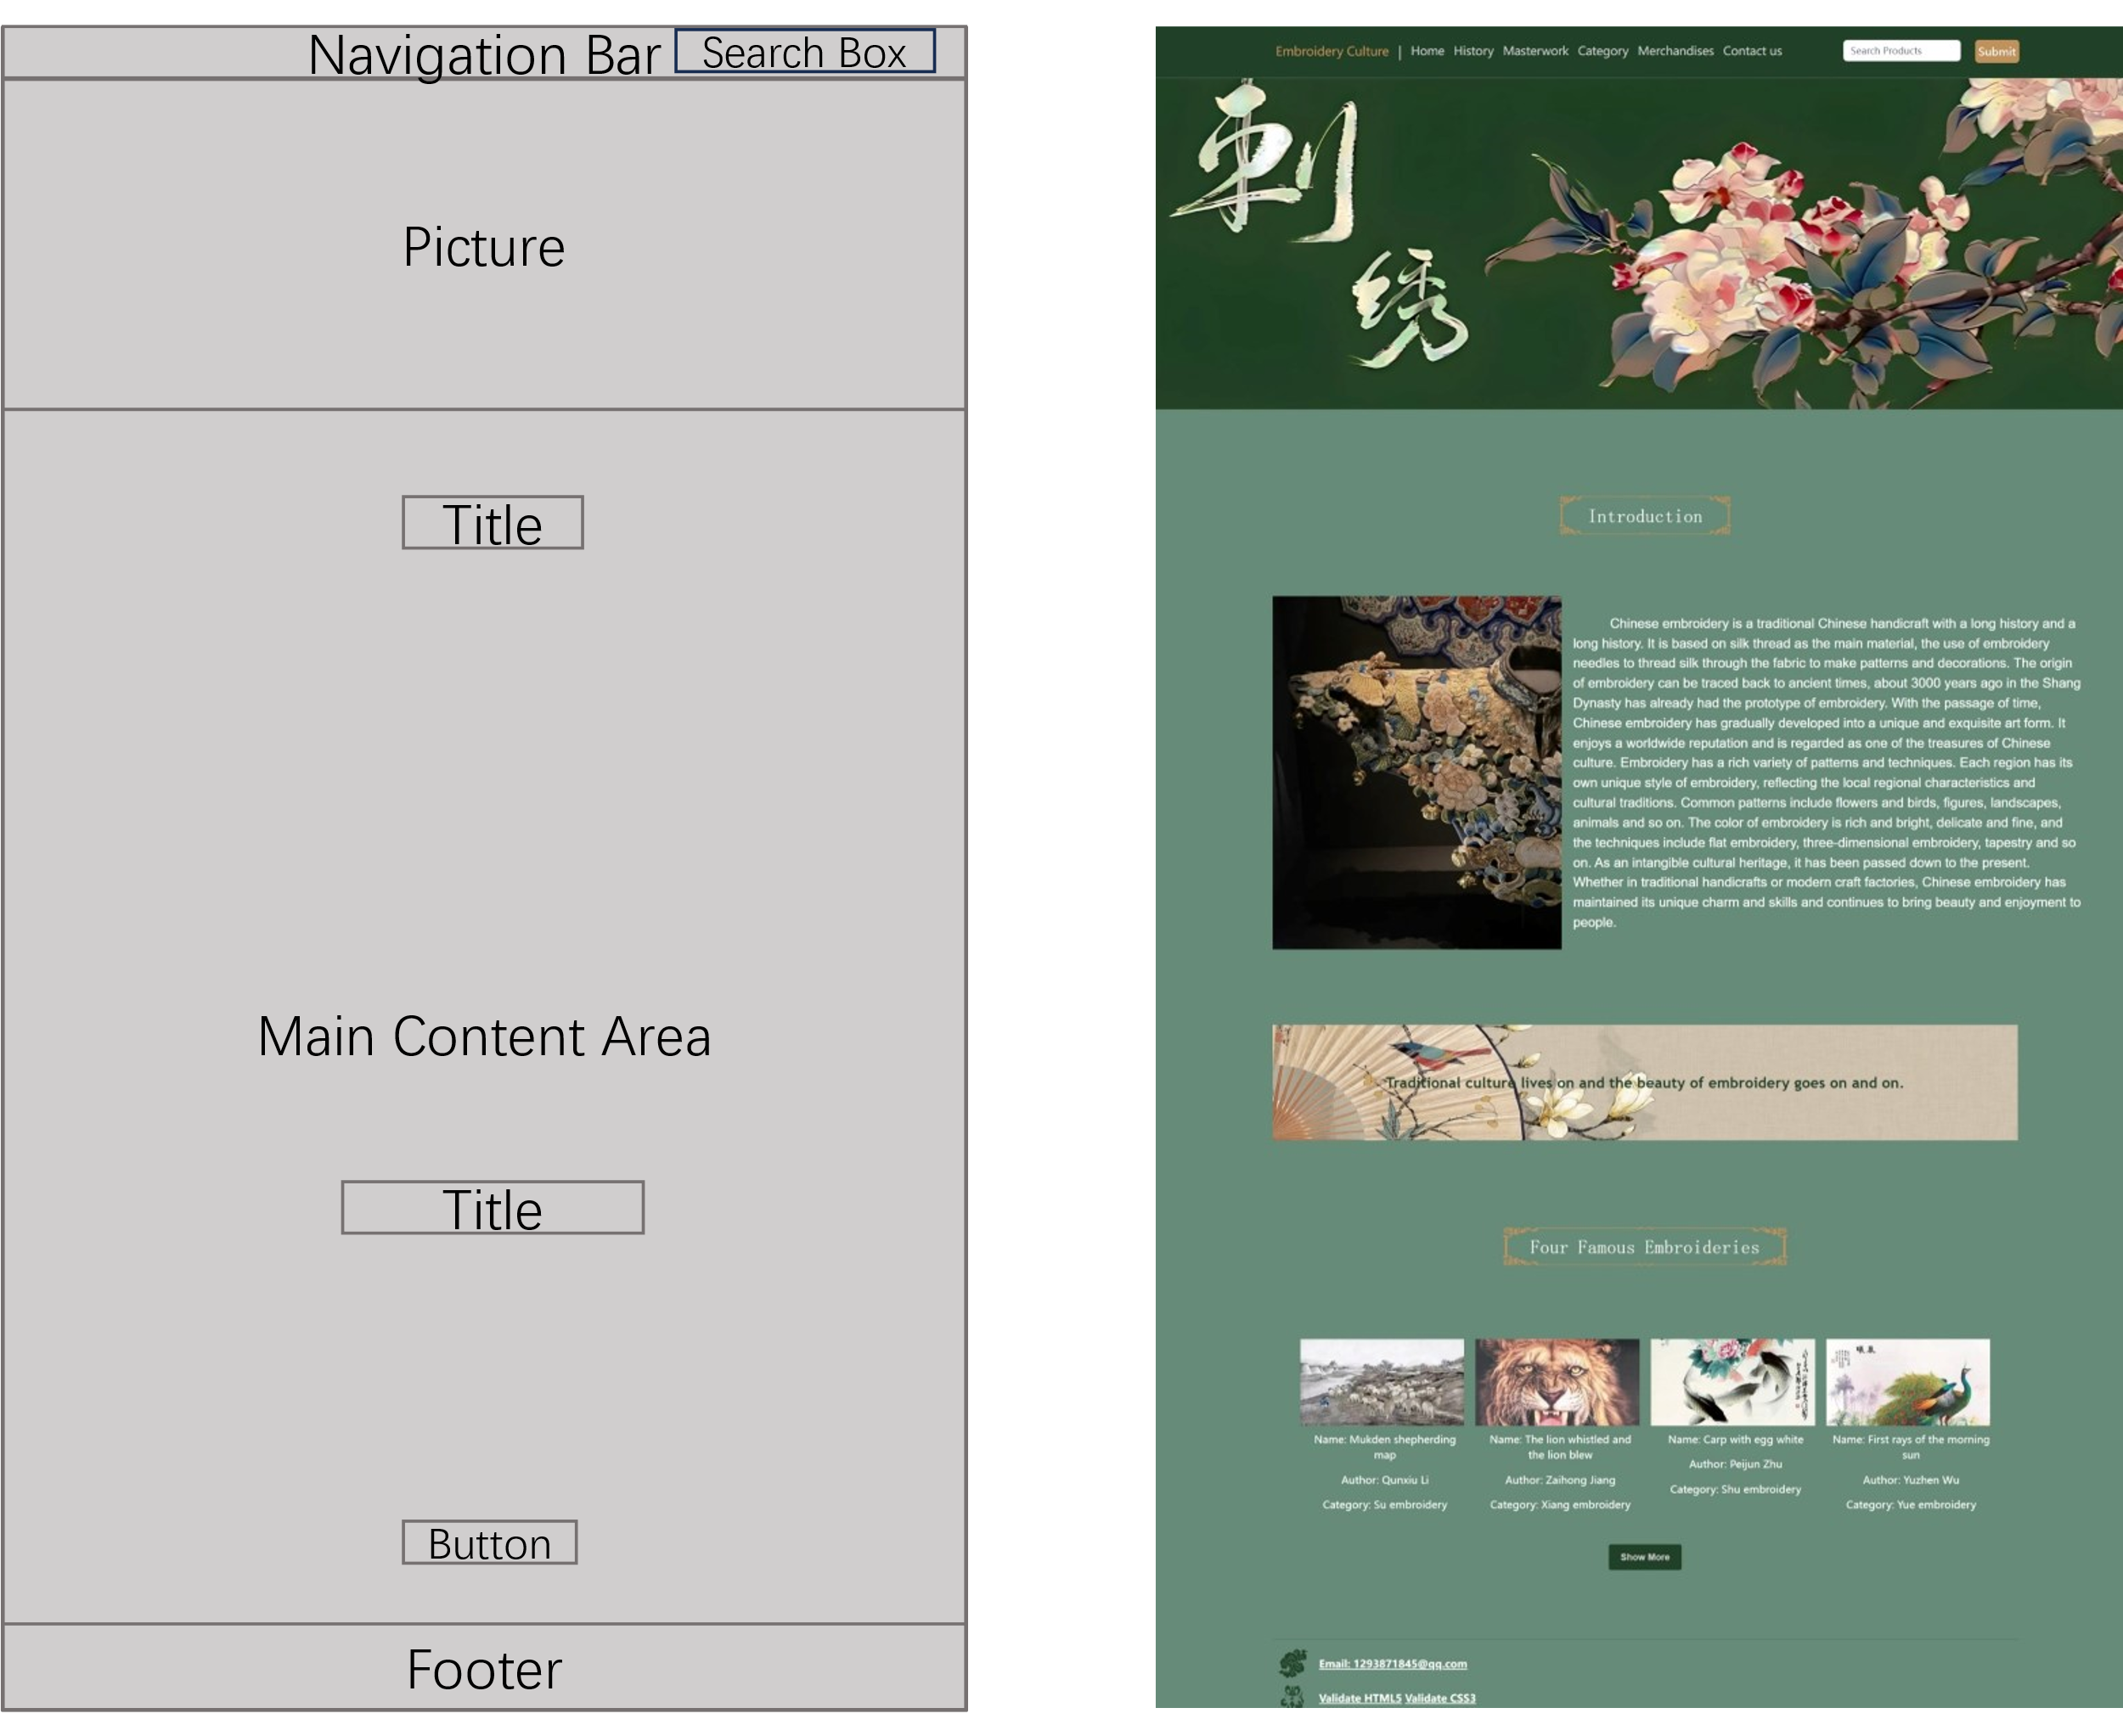

## History

This page introduces the development history of Chinese embroidery from the Warring States Period to the Qing Dynasty, as well as the characteristics of each period.

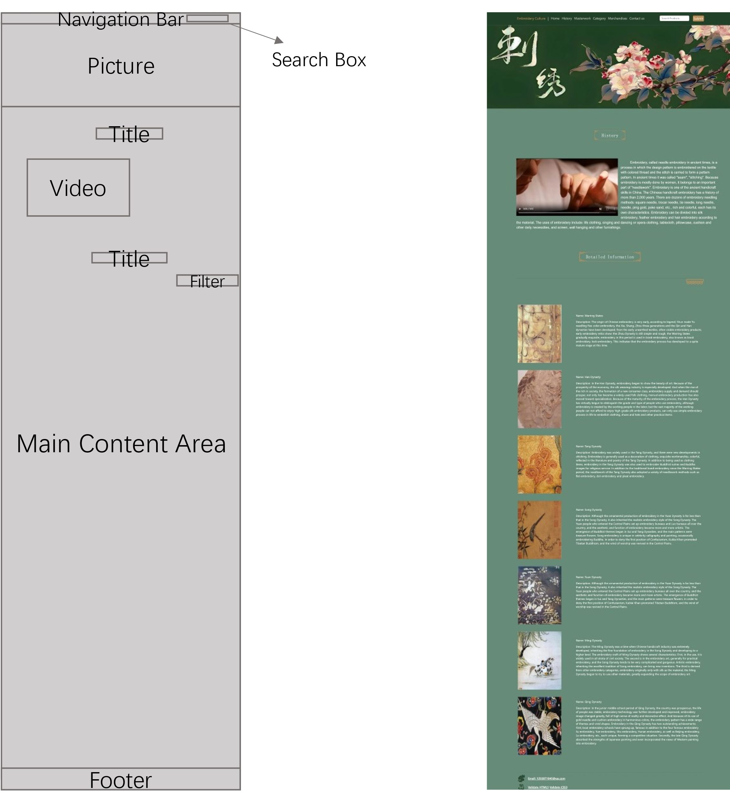

## Masterwork

This page introduces the most representative and famous works of the four famous embroideries, including their authors, eras, types and characteristics.

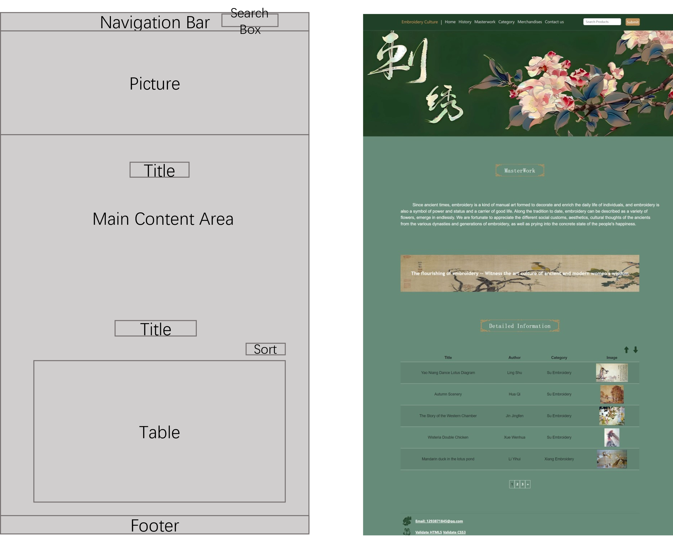

## Category

This page for the website to provide the goods to the four famous embroidery as the standard for classification, and briefly describes the characteristics of the four famous embroidery.

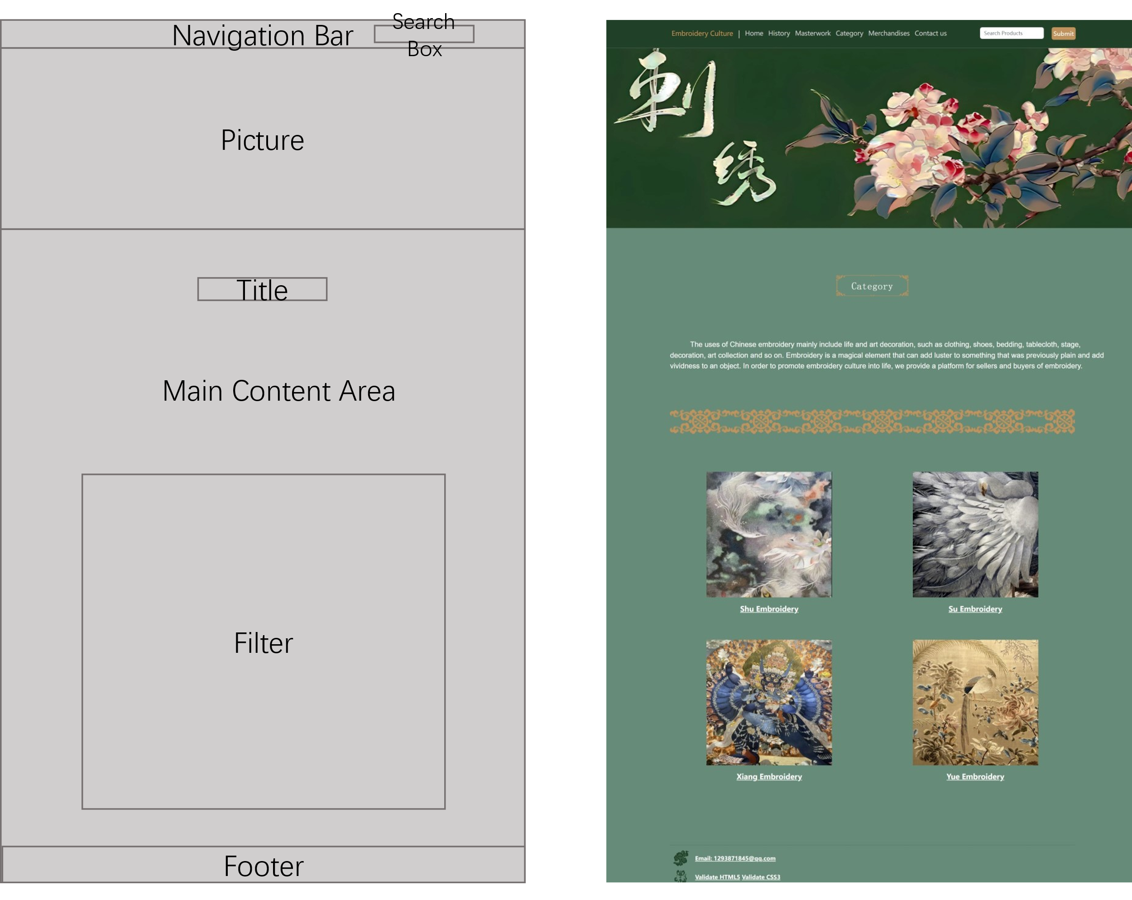

## Merchandises

This page describes all the products offered on this website, including their physical drawings, types, names, prices and features. The preservation method of embroidery is also provided.

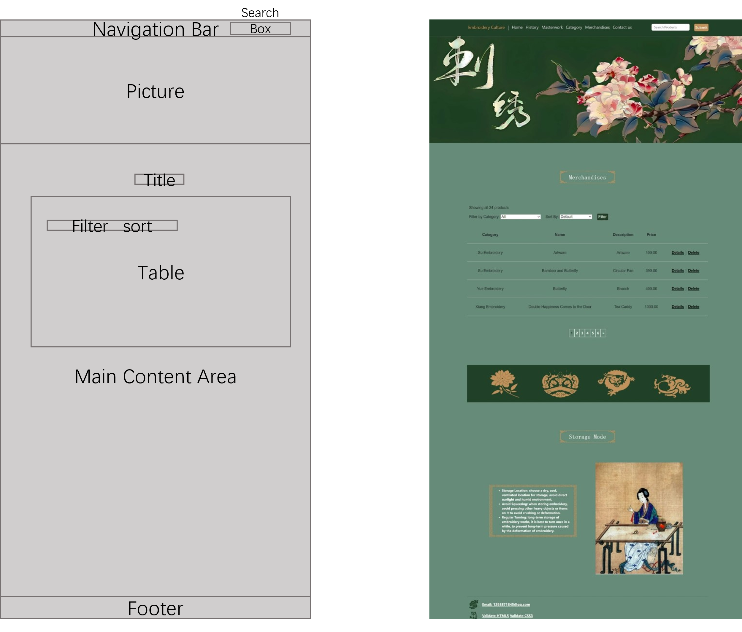

## Contact us

This page provides contact emails to this website that can provide you with your experiences and ideas about embroidery.

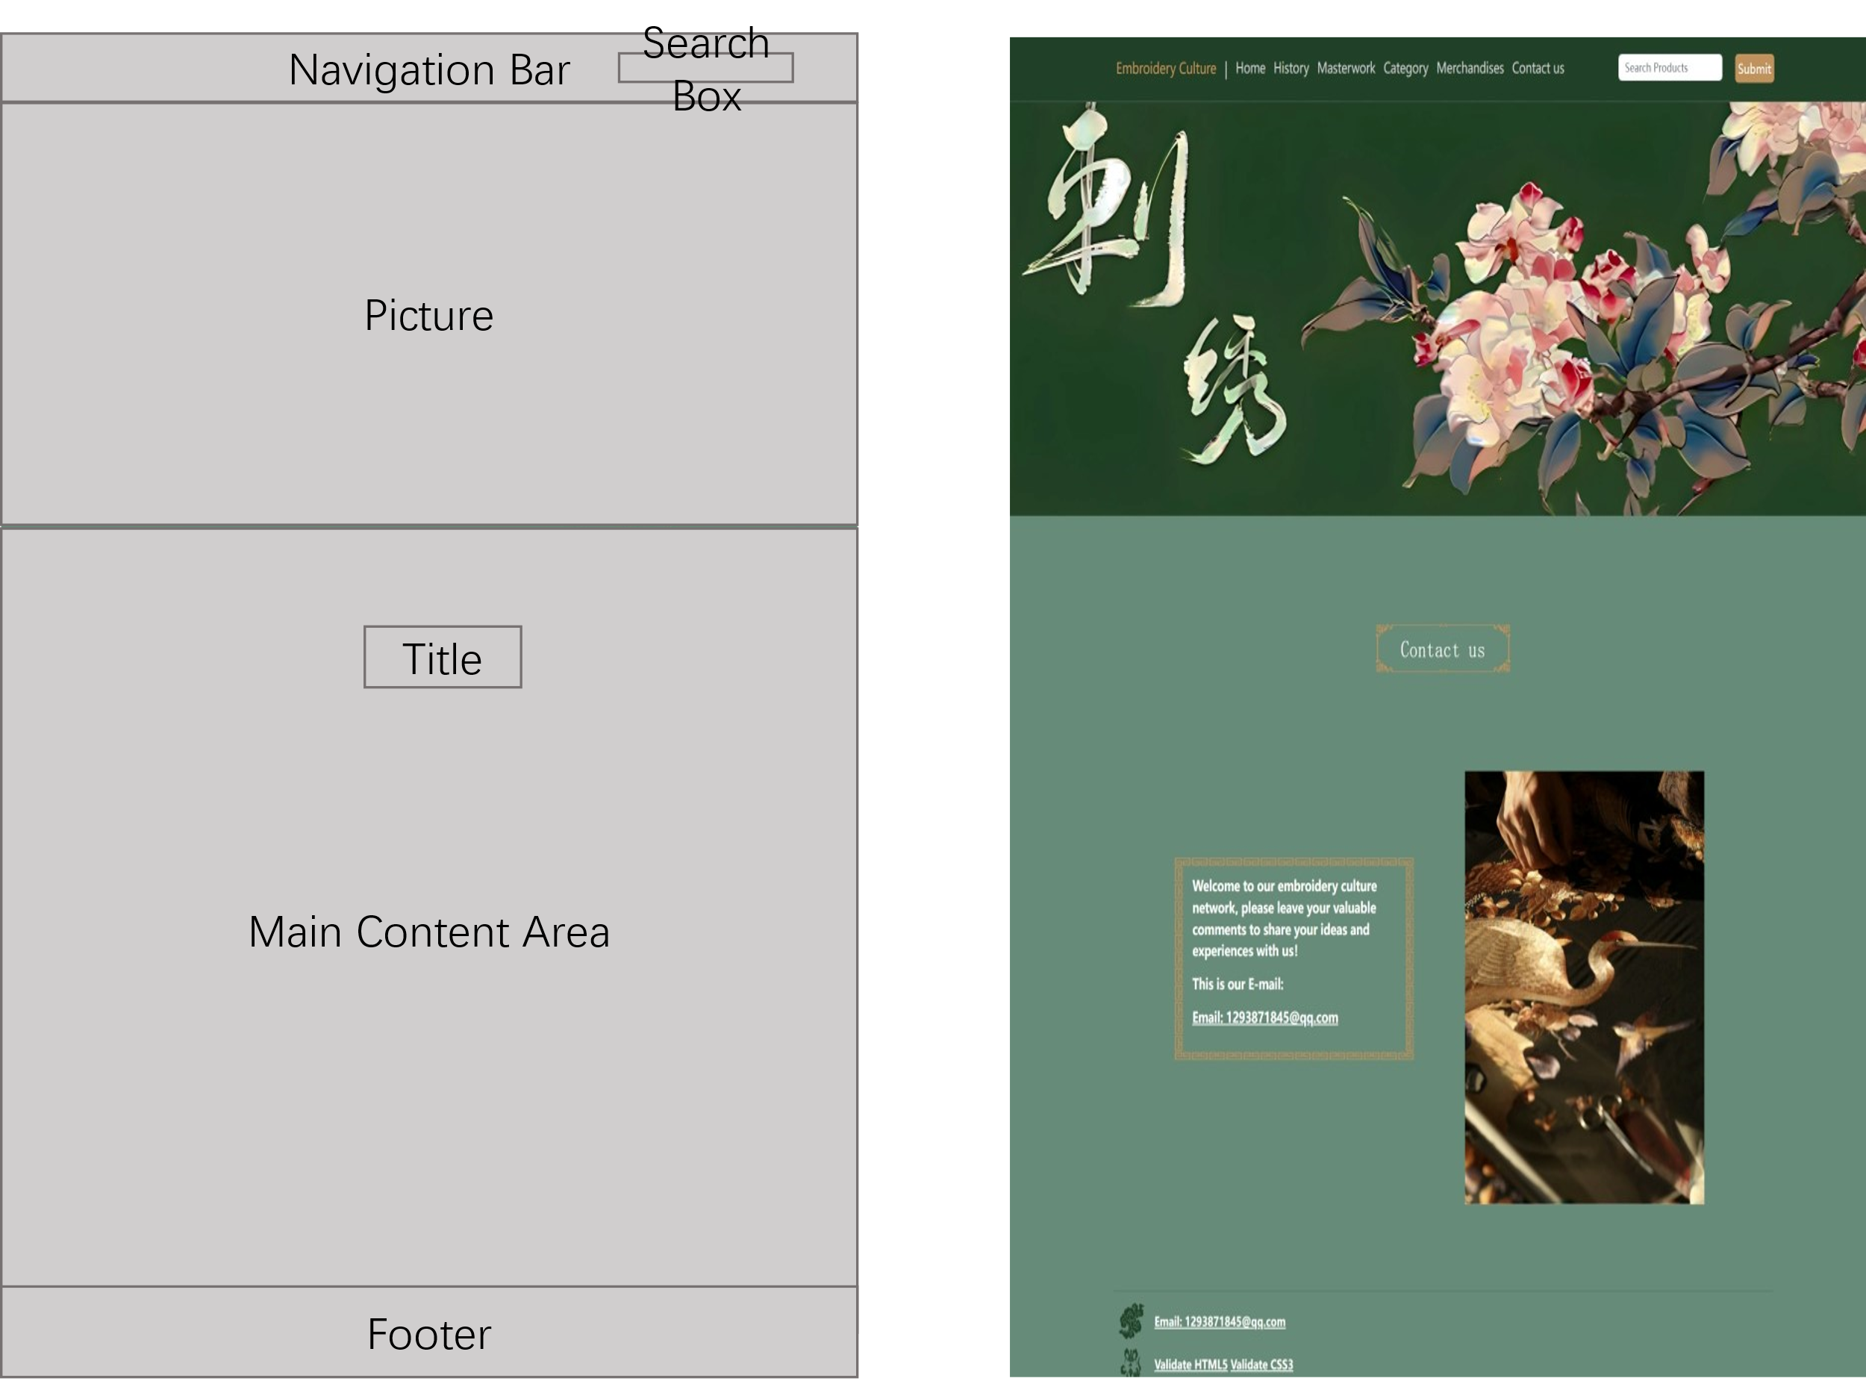

# Utilizing Website Features

## Home

The function of the Home page is shown below:

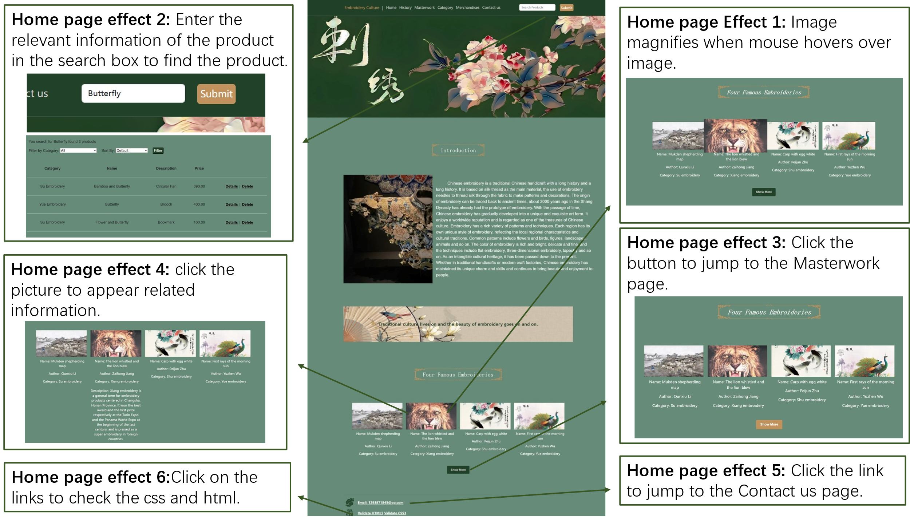

## History

The function of the History page is shown below:

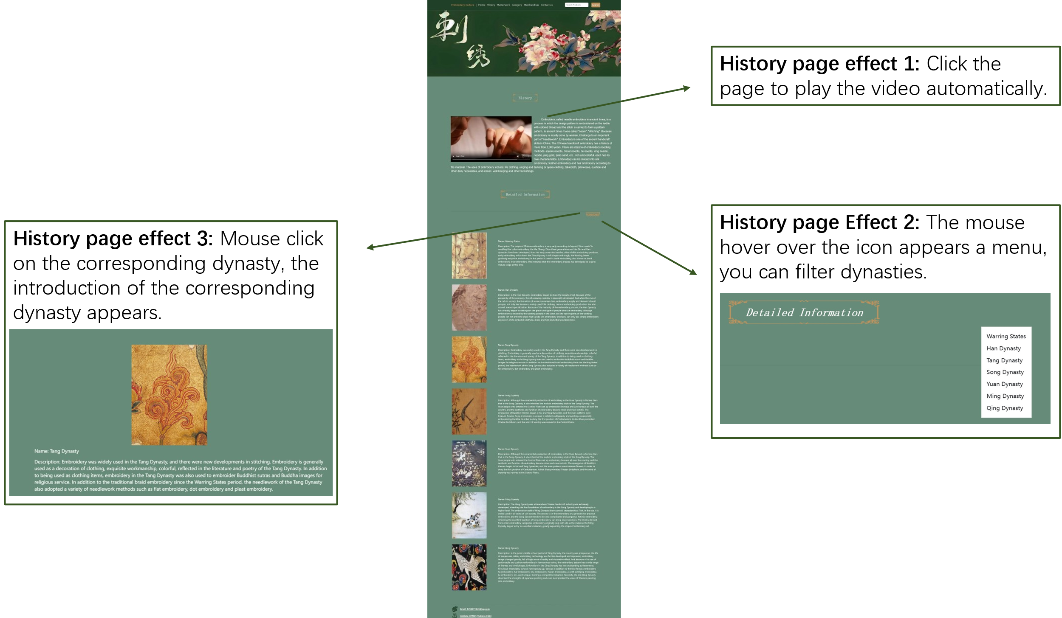

## Masterwork

The function of the Masterwork page is shown below:

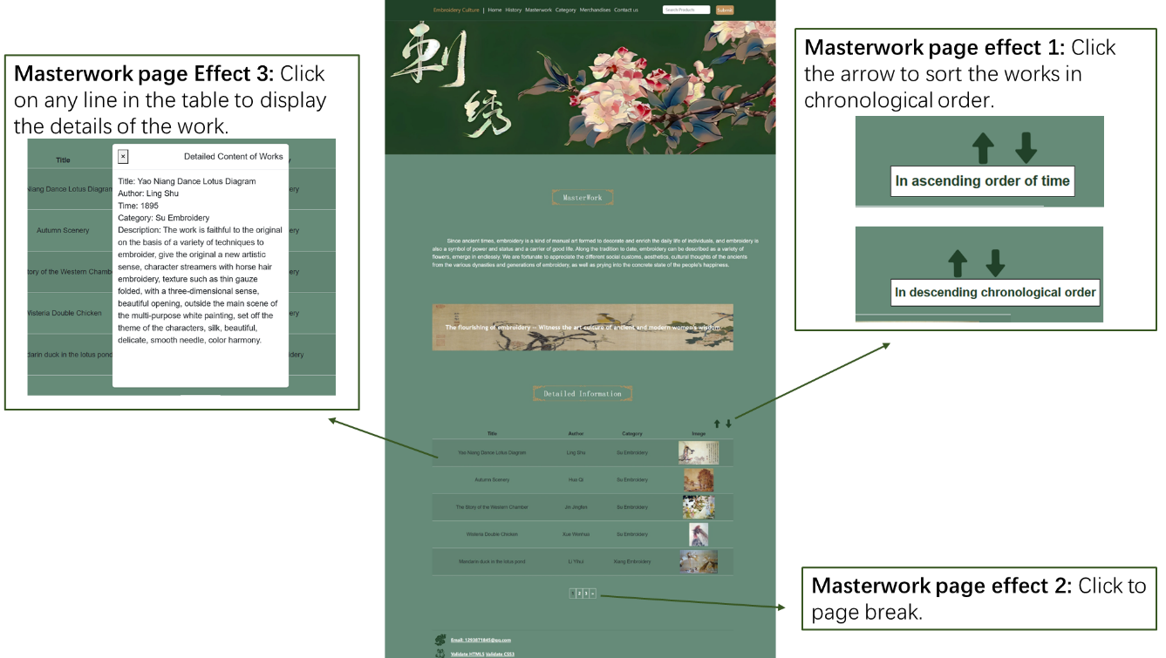

## Category

The function of the Category page is shown below:

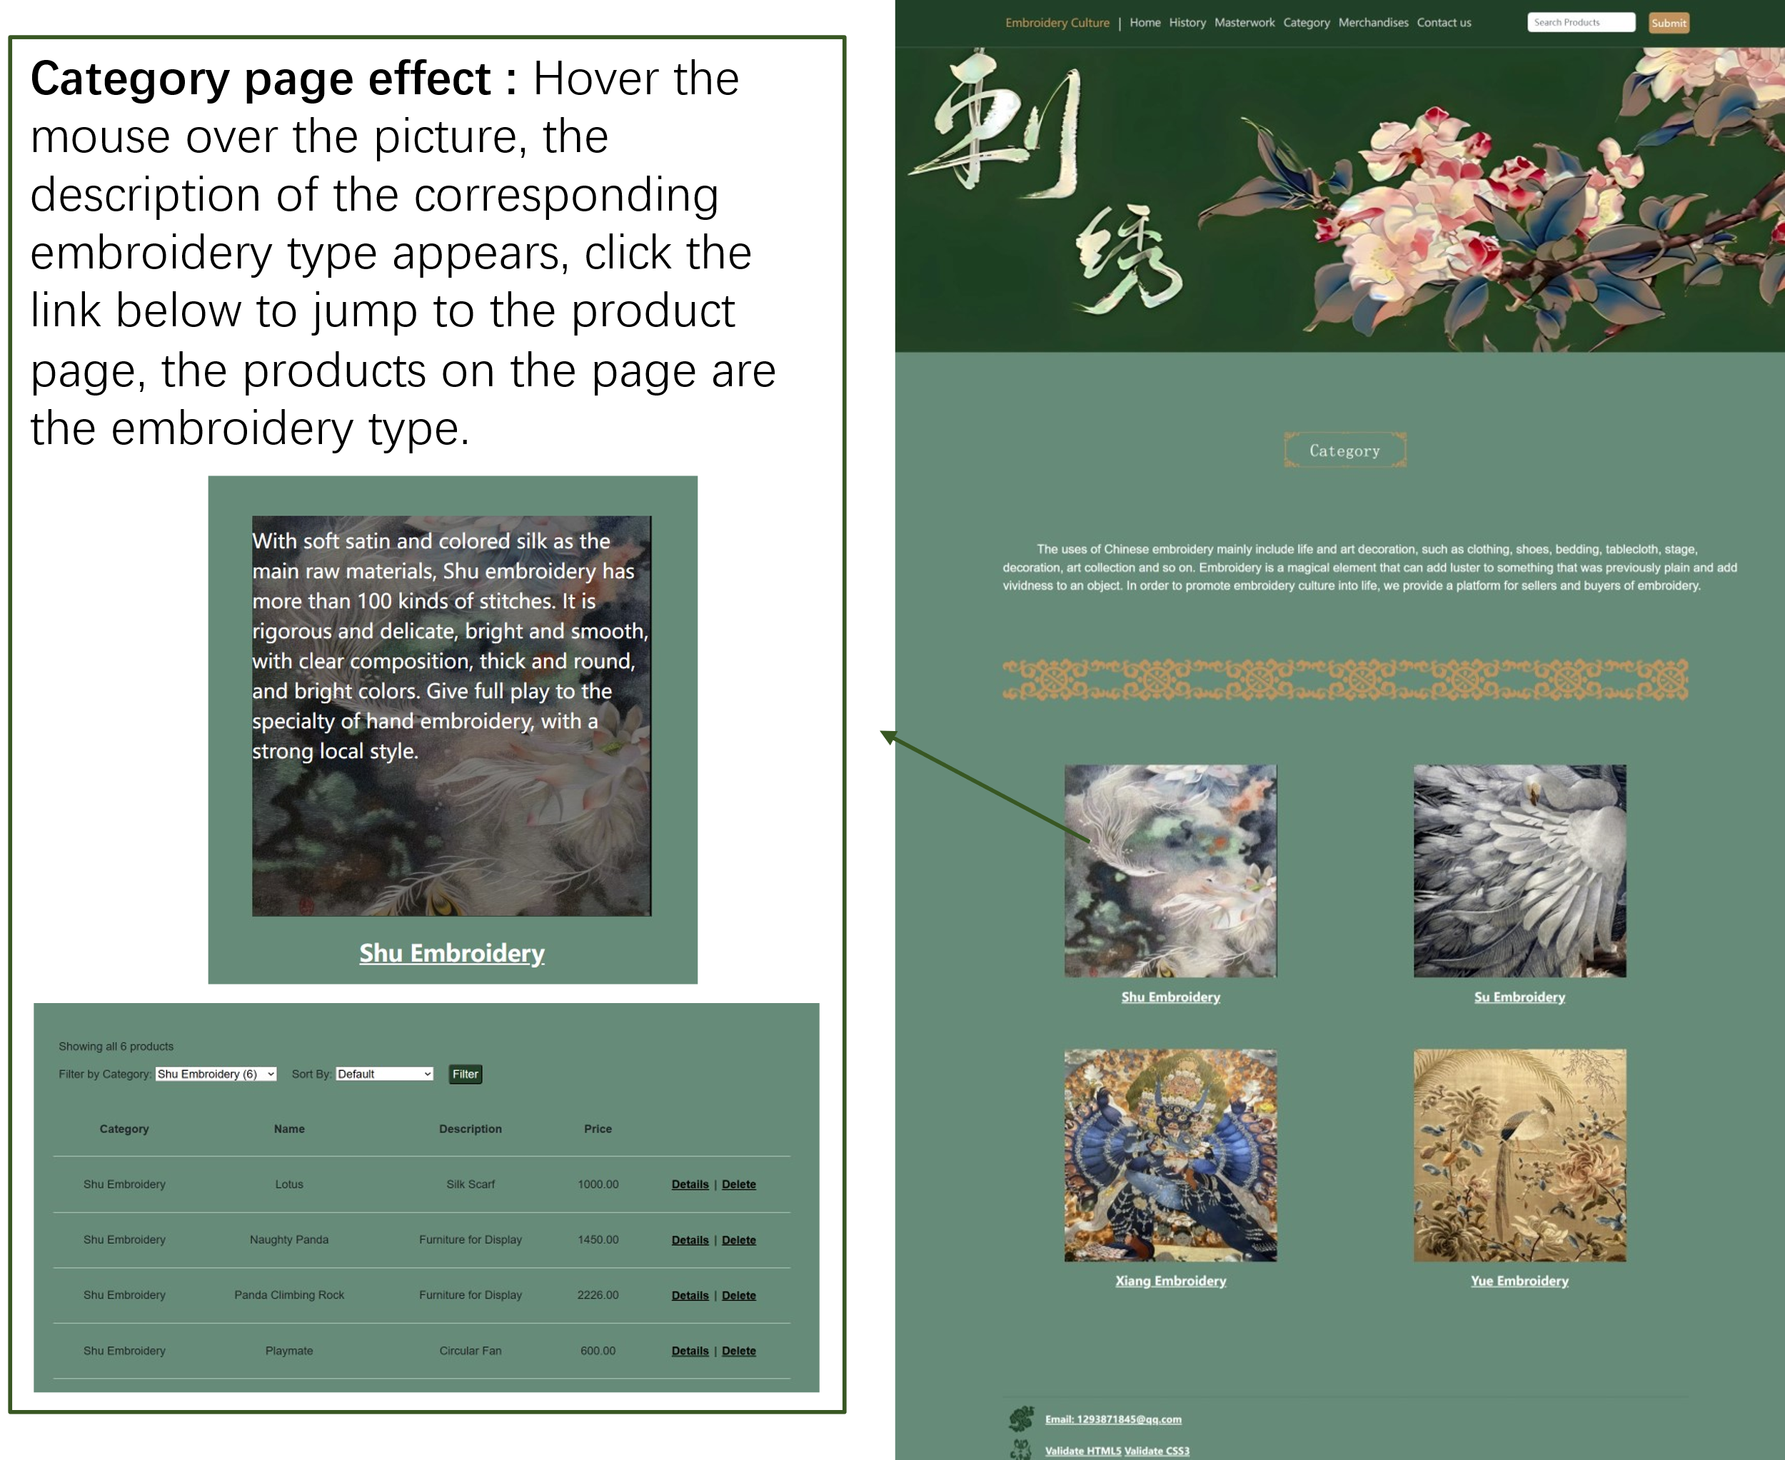

## Merchandises

The function of the Merchandises page is shown below:

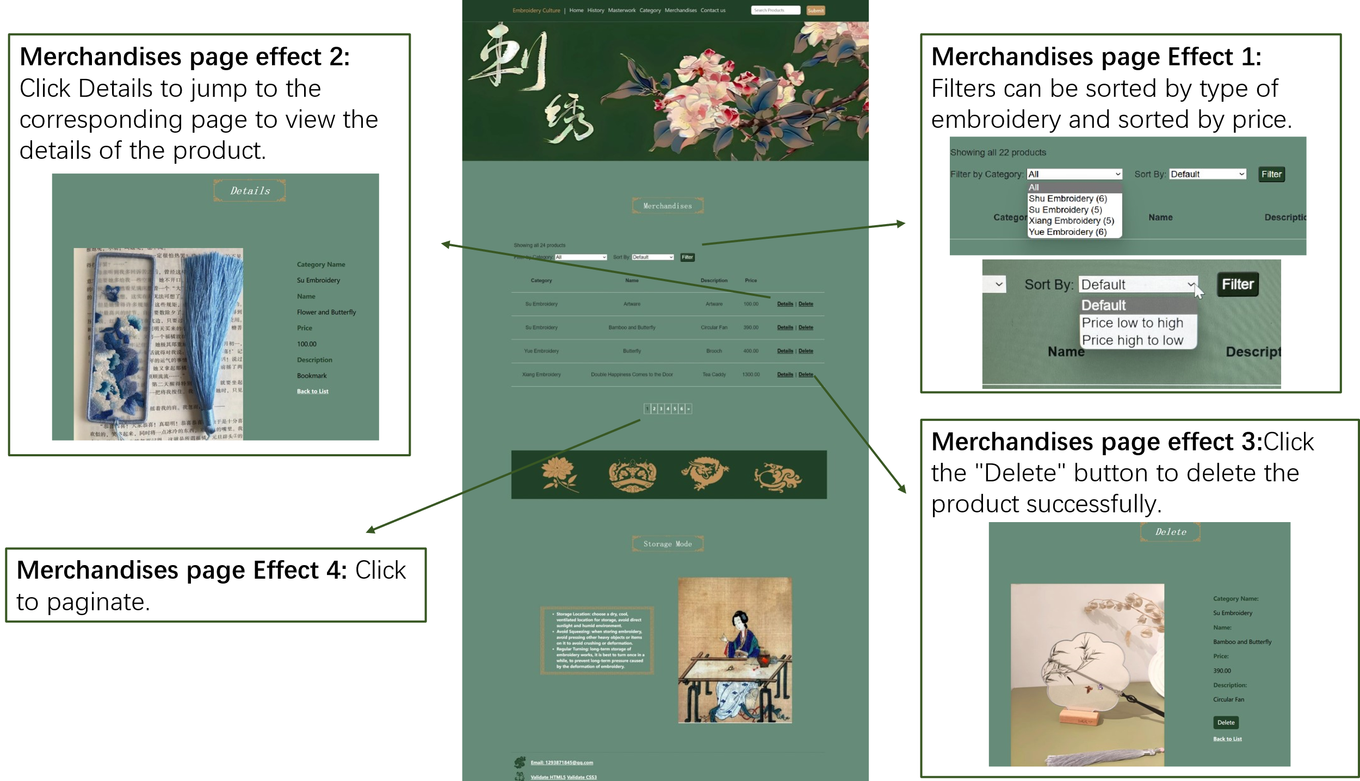

## Contact us

The function of the Contact us page is shown below:

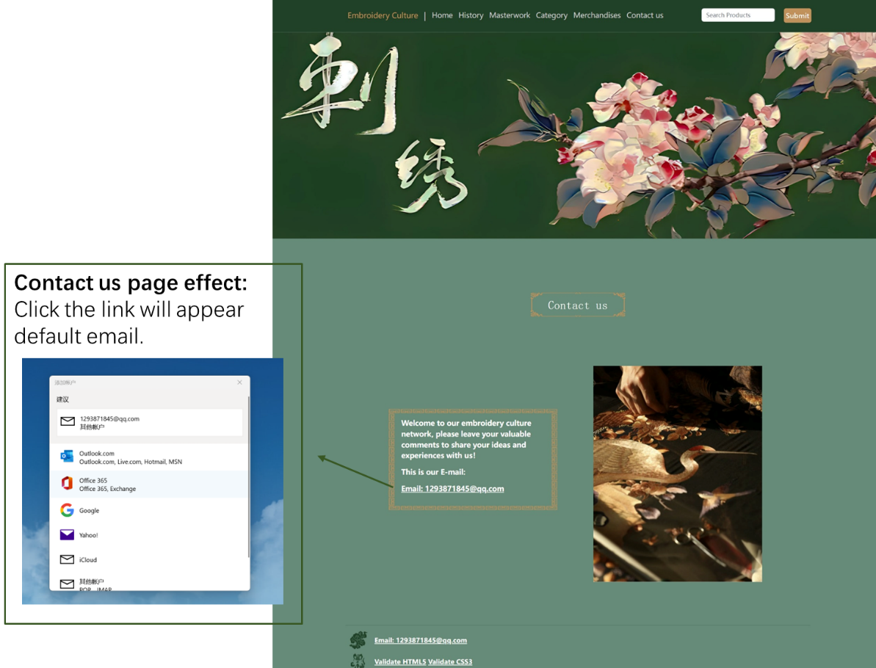

# Technical Demonstrations

## Models

### Category

1. **Model:**

A model is a class that represents a database table. The Category class is used to represent the categories of products. It contains attributes such as ID, Name, ImageUrl, and D to store category-related information. In addition, it has a Products property that is used to navigate to the collection of products associated with that category. In the application program, the database table can be operated through the model, such as adding, deleting, updating and querying data.

**2、Relationships:**

Relationships are used to describe associations between models. There is a one-to-many relationship between the Category and Product classes. This relationship is implemented in the model by defining a Products property in the Category class, which represents the set of products associated with that category. By defining this relationship in the model, you can more easily process the associated data during database operations.

**3、Seeding Data for Testing Purposes:**

Data seeds are used to populate data during database initialization or testing. In this model, seed data is used to initialize the Category table. In the Seed method of the Configuration class, a list of Category objects is created that contains some initial category data. This data is then added to the Category table in the database using the AddOrUpdate method. In addition, data is prevented from being added repeatedly each time the migration is run by specifying the Name property as the matcher. In this way, initial data can be created in the database for use during testing or initialization.

### Product

1. **Models**

The database model used on the website is the Product model. The model has the following attributes:

ID: Unique identifier of the product, used as the primary key.

Name: indicates the name of the product.

Price: The price of the product.

Description: Description of the product.

ImageUrl: The image URL of the product.

CategoryID: indicates the category ID of the product.

Category: The category object to which the product belongs.

**2、Relationships**

One-to-many relationship between Product and Category: A product can belong to only one category, while a category can contain multiple products. This relationship is implemented through the CategoryID property and the Category navigation property. The foreign key (CategoryID) associates the Product table with the Category table, and the navigation property (Category) allows access to the relevant category information at query time.

**3、Data Seeding for Testing Purposes**

In this model, each product has a unique name, description, price, and category information. In the code, use the AddOrUpdate method to match each product with its name to avoid adding duplicate products.

Through database models, relationships, and data populate, websites can integrate and use databases to manage and present product information. A product model defines the properties of a product and associates them with categories. A one-to-many relationship allows a product to belong to a category and allows a category to contain multiple products. In this way, the website can effectively manage and display products and provide users with a good shopping experience.

## Css

### Color

Pages are mainly dark green (# 214129), light green (#668B78), yellow (#C1925B), grey (# ccc).

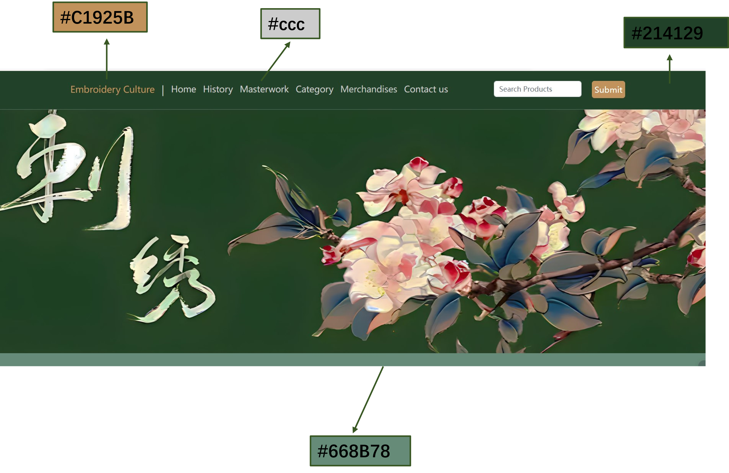

### Title

Set the width to 100%, the text is centered, displayed as an inline block element, the background uses an image with a url, the image size is the same as the parent container, the text color is white, the font size is 32px, the font is serif, the font style is italic, bold, and bold.

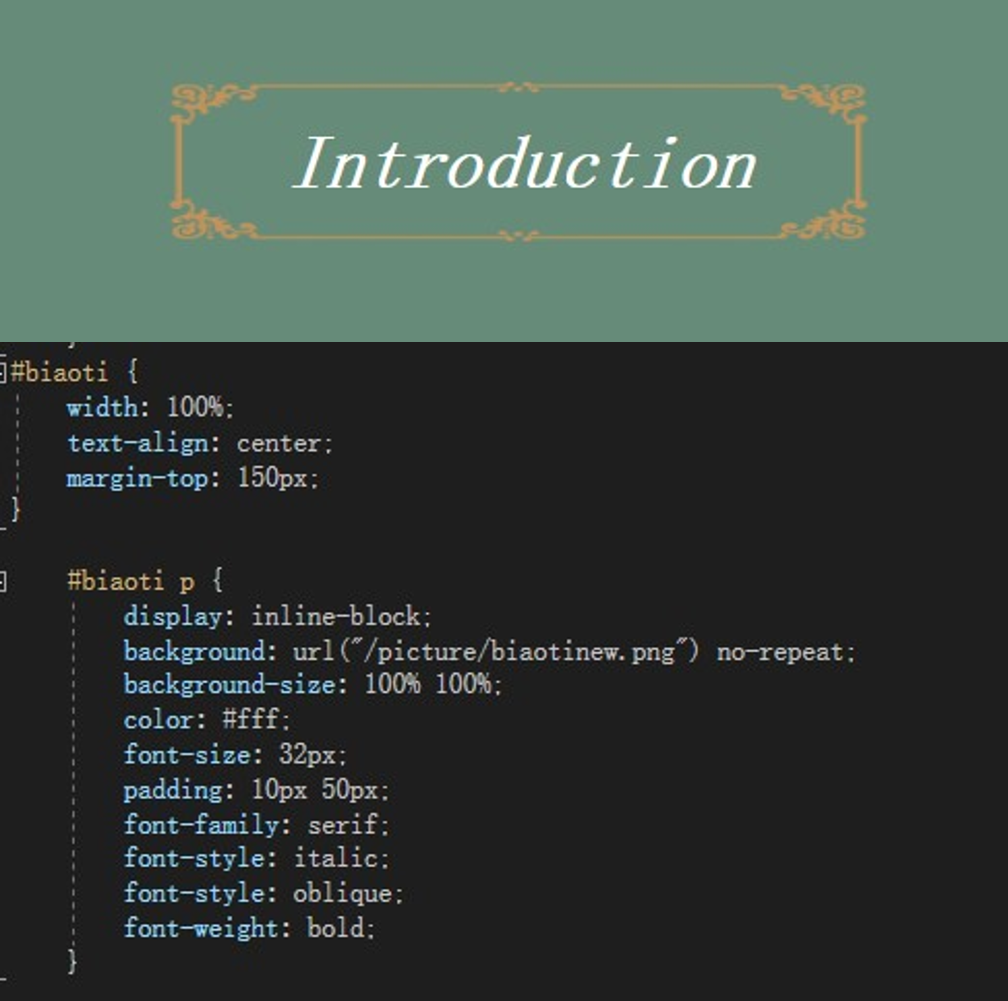

### Text

Generally in white, Arial font.

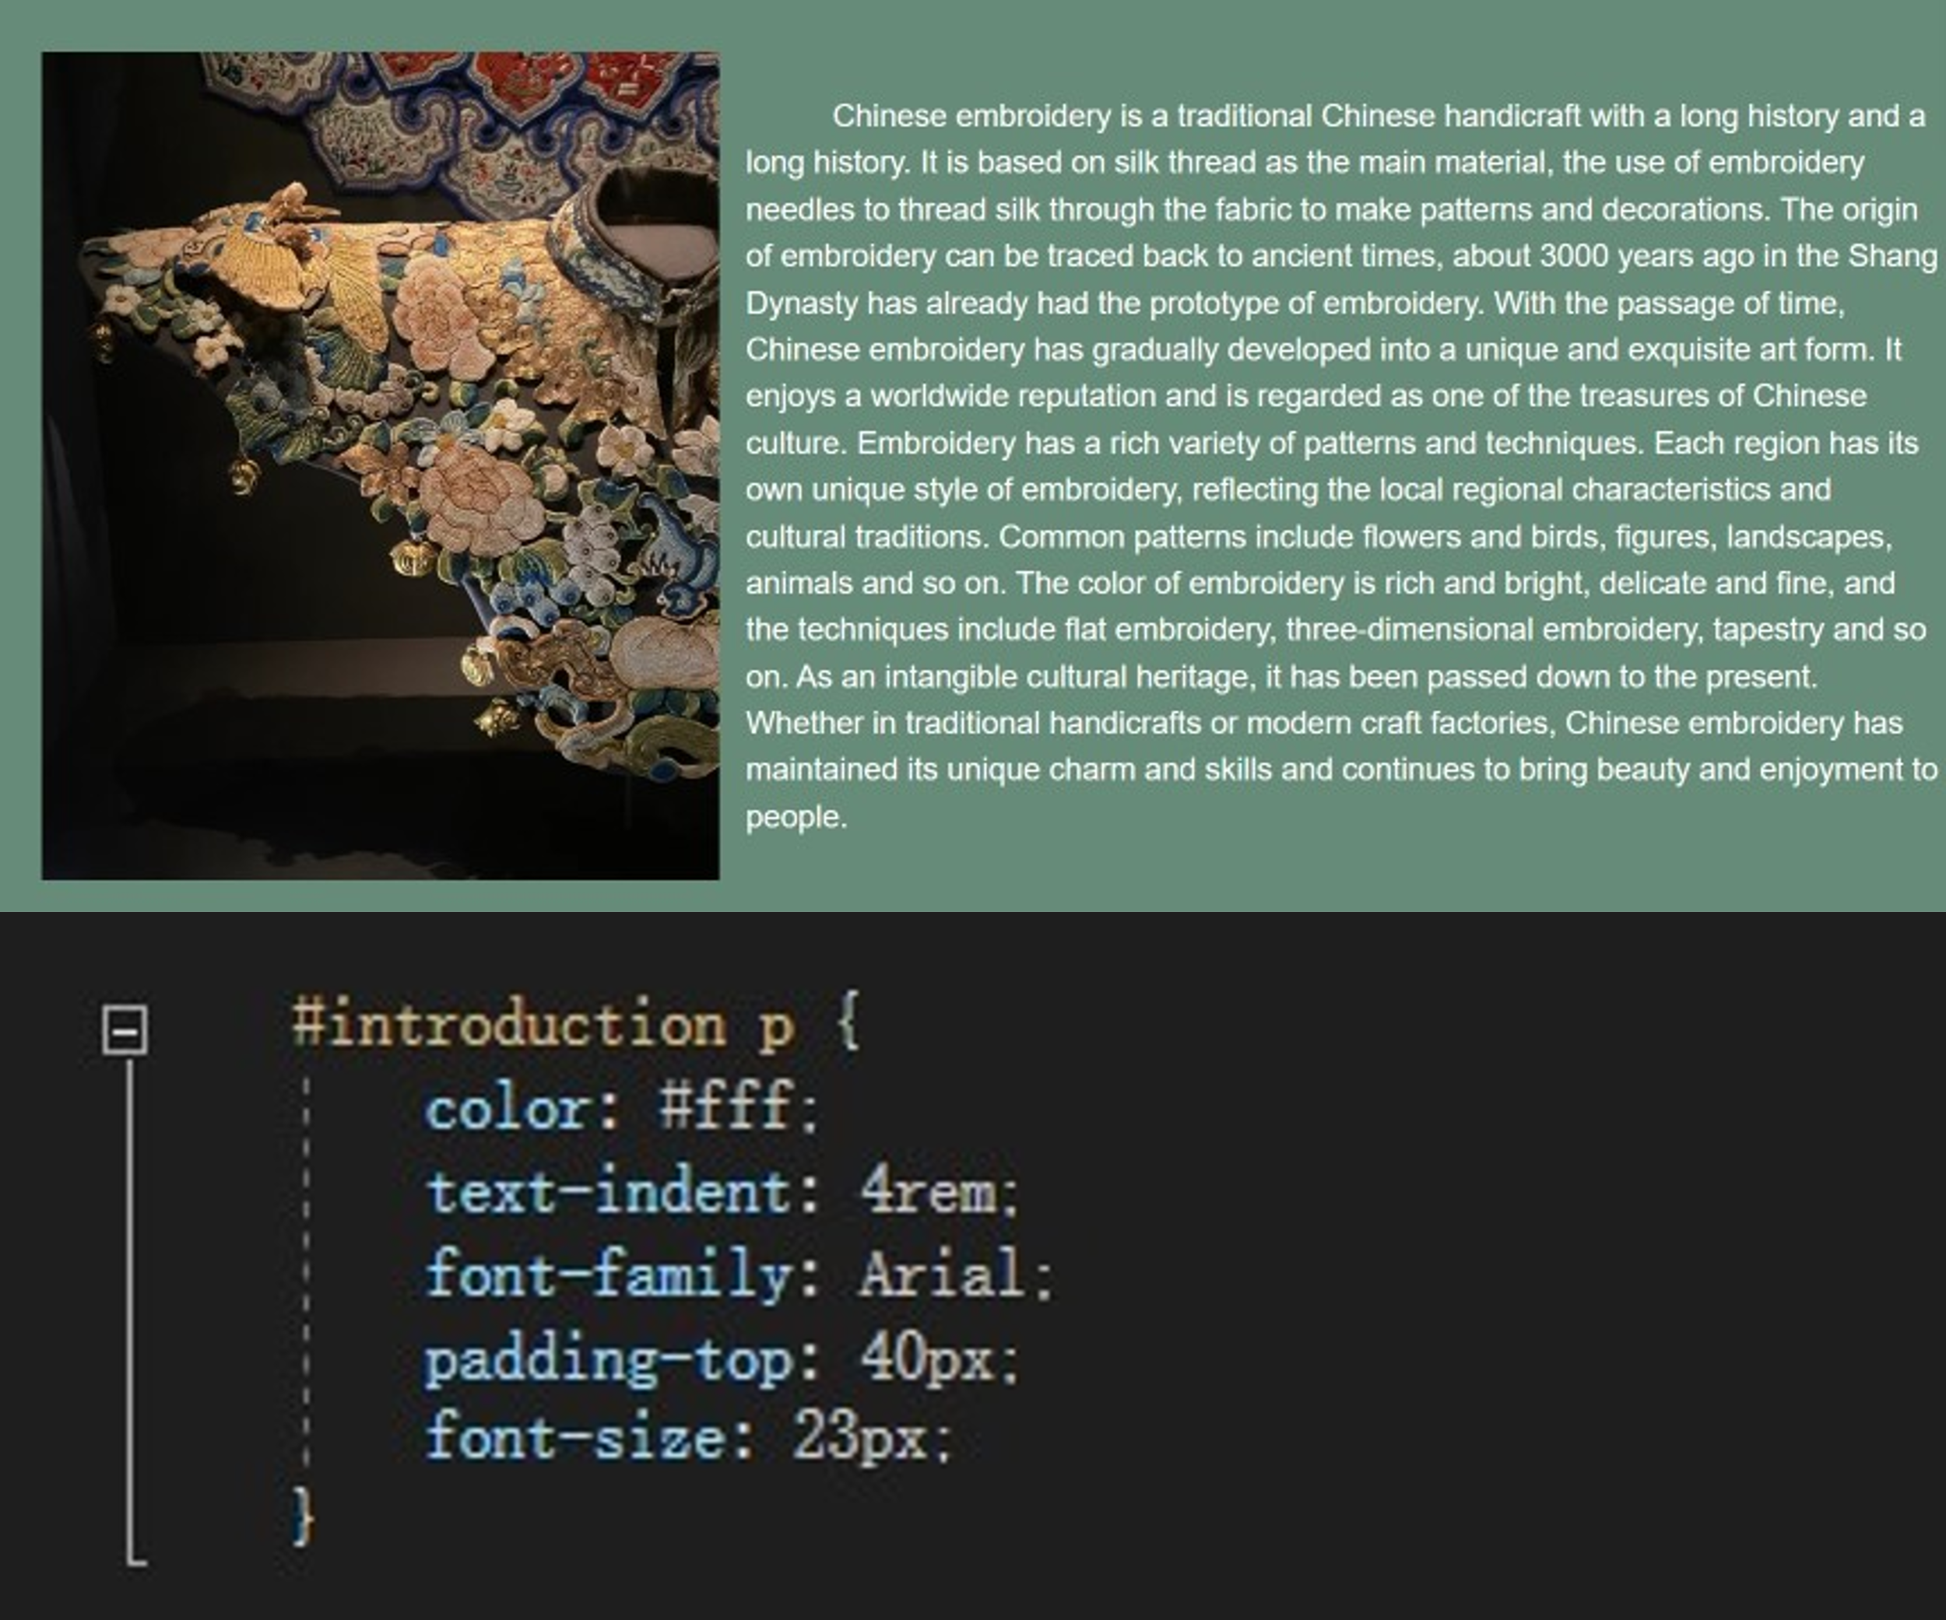

### Table

Set the text in the table to be centered, use the Arial font, and set the line height of each row element in the tbody of the table to 4, the td and th elements in the table to be vertically centered, and the font size to 20px.

The pager container has the Flex layout set, and the content is centered horizontally and vertically, the a label in the pager is set as an inline block element, the inner margin is set to 8px, the border is set to 1px white solid line, the text color is white, no underline, the font size is 17px, and the font is bold.

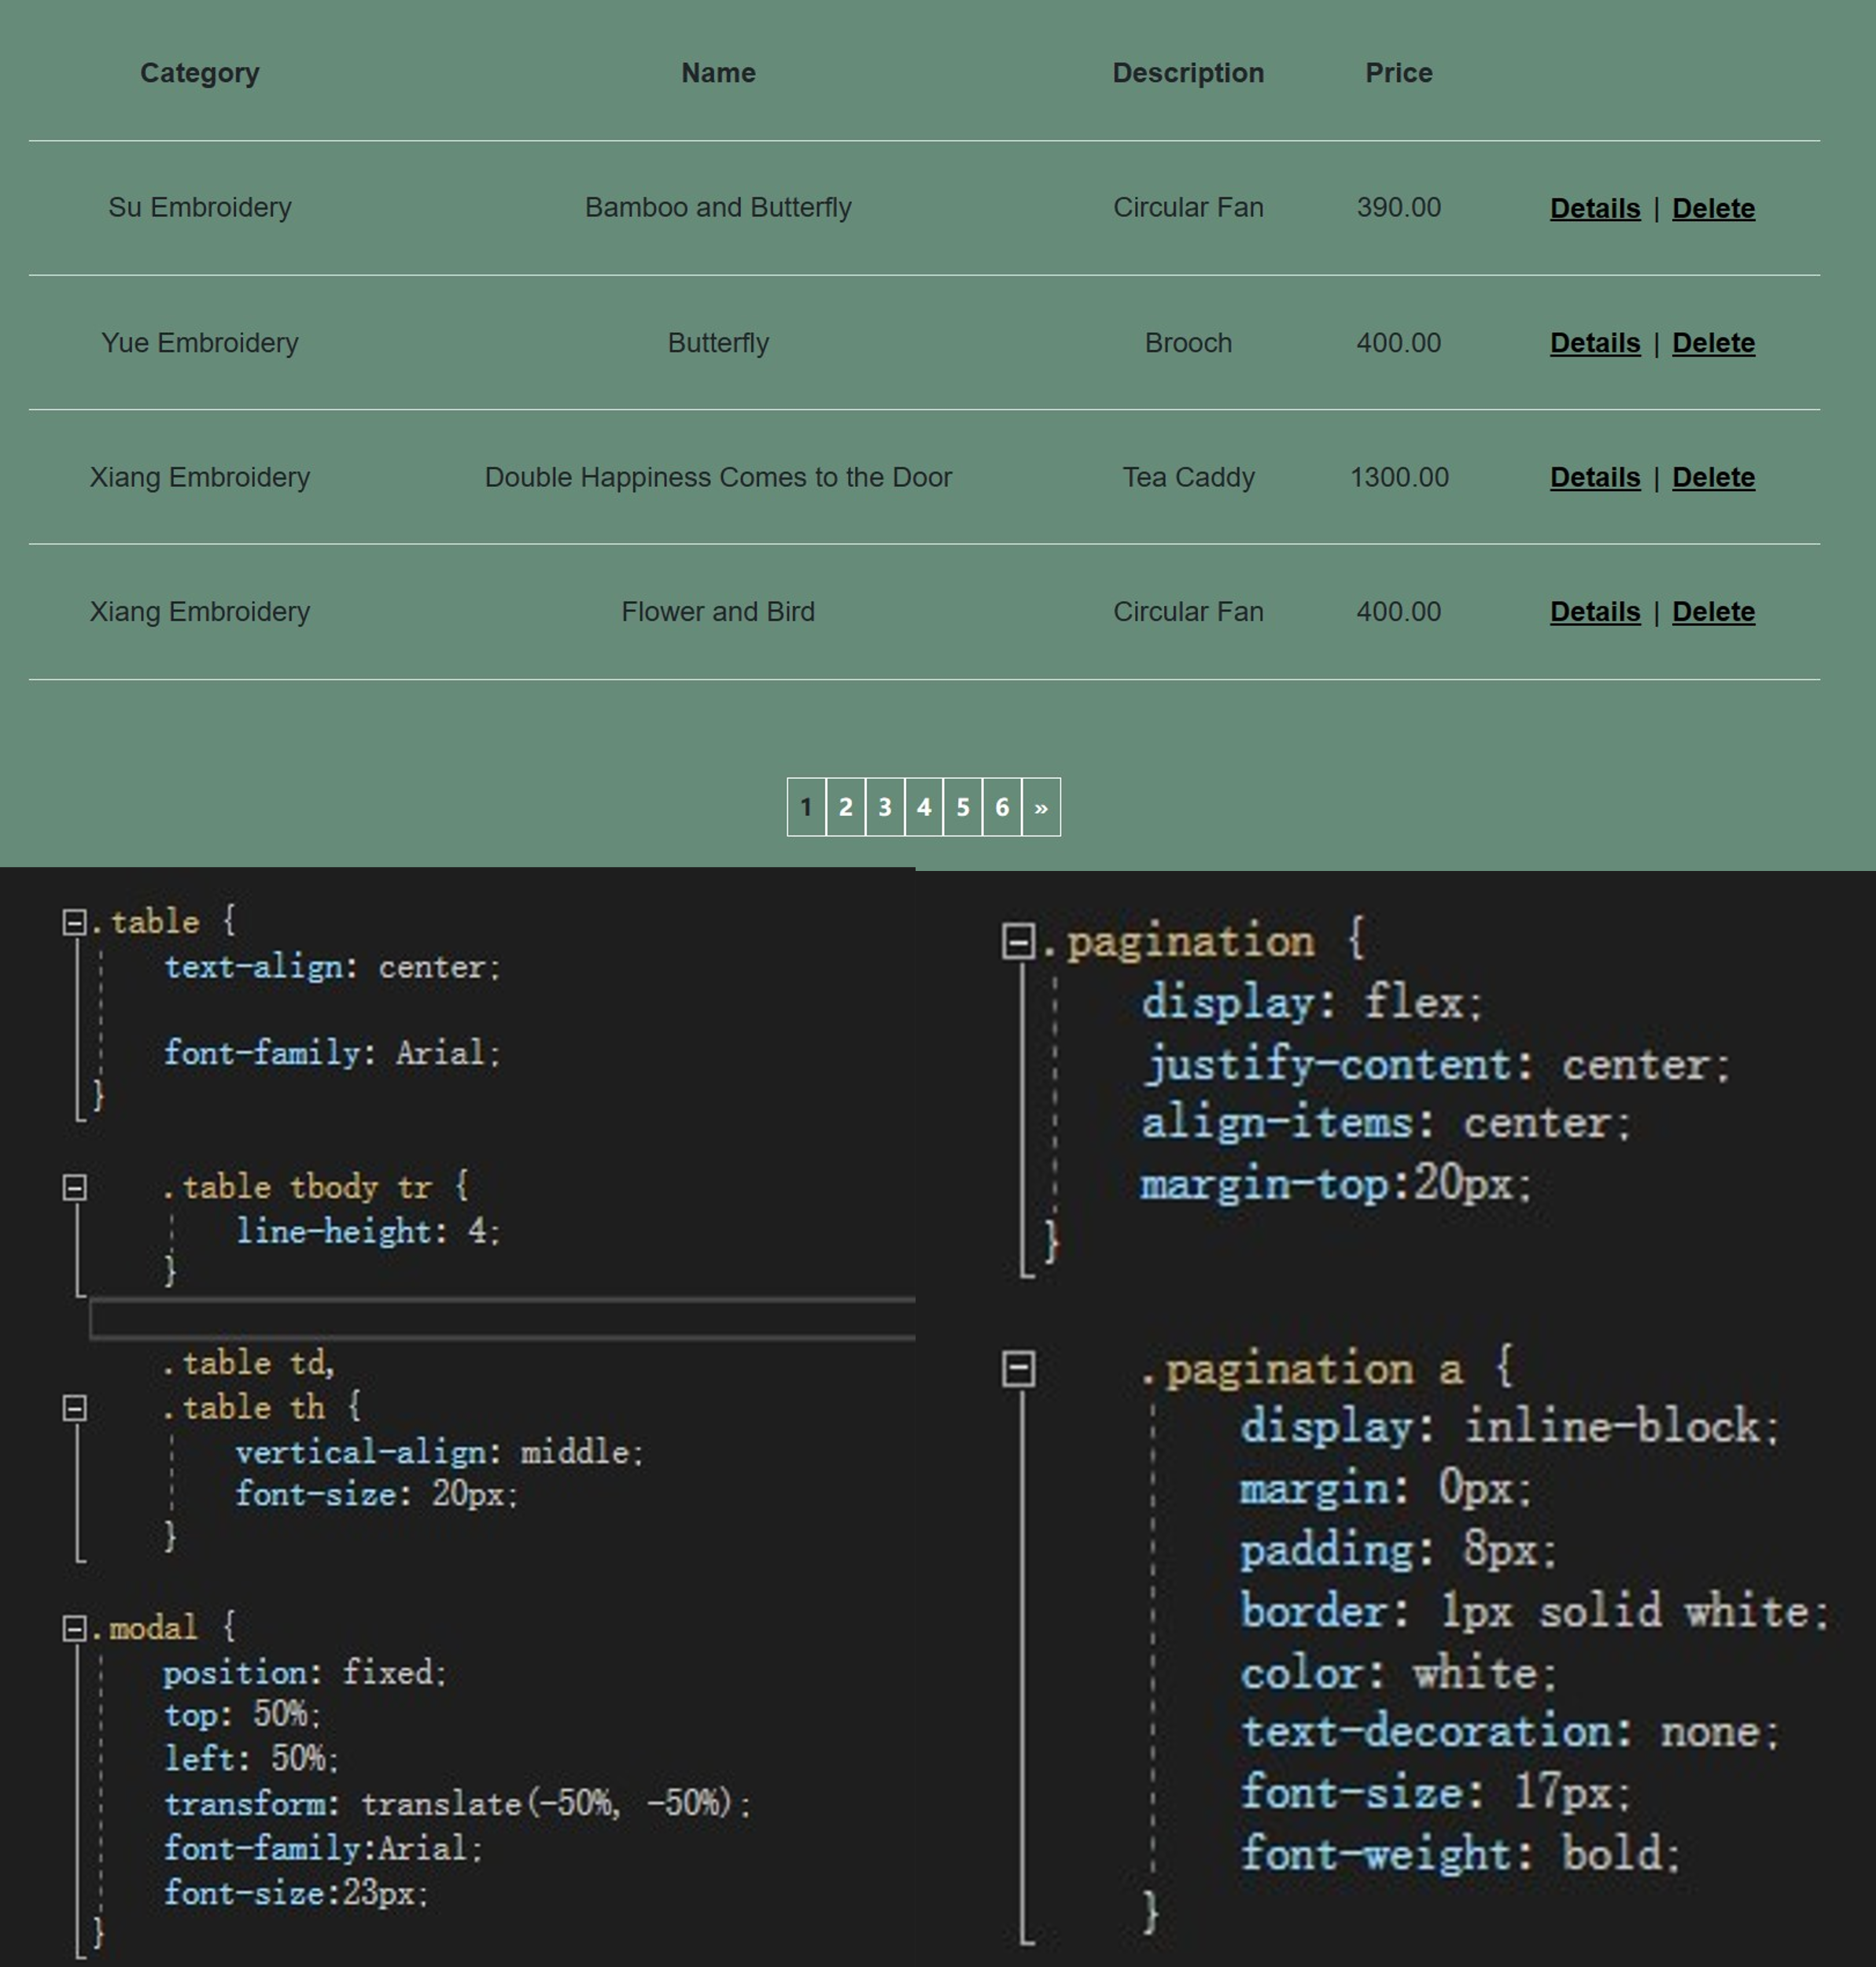

### Link

Hover color change.

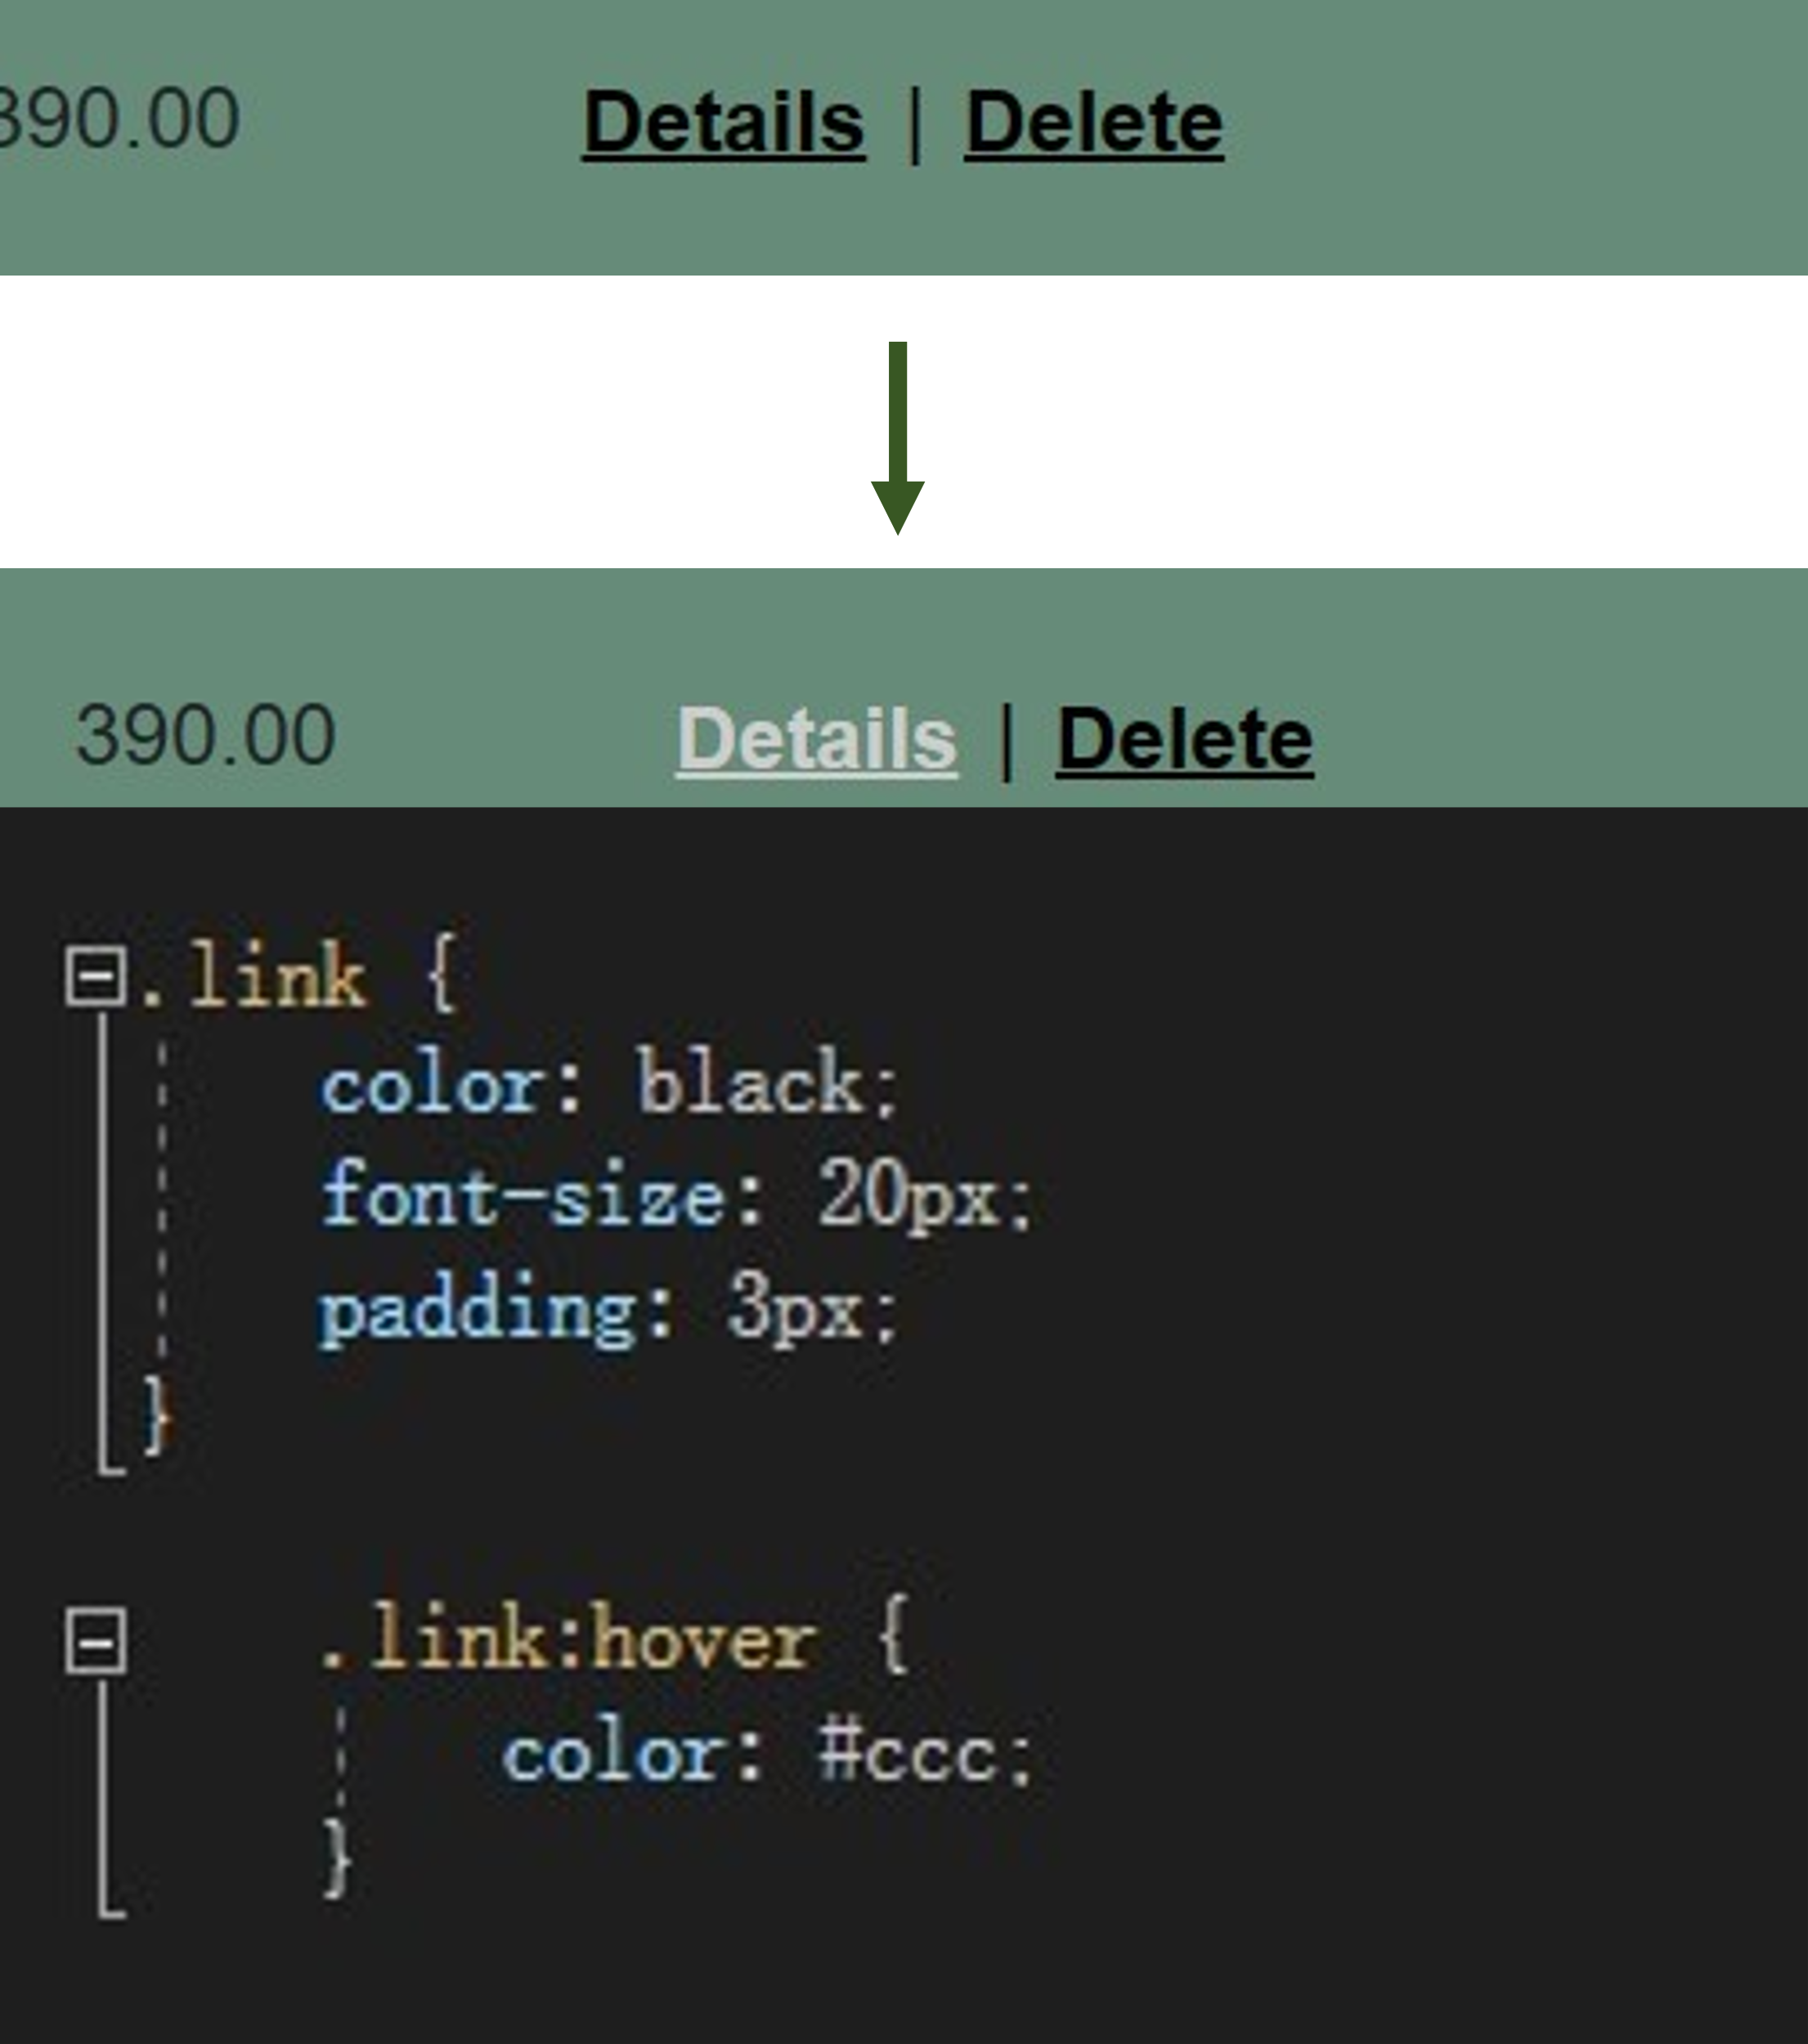

### Button

Click and hover to change color.

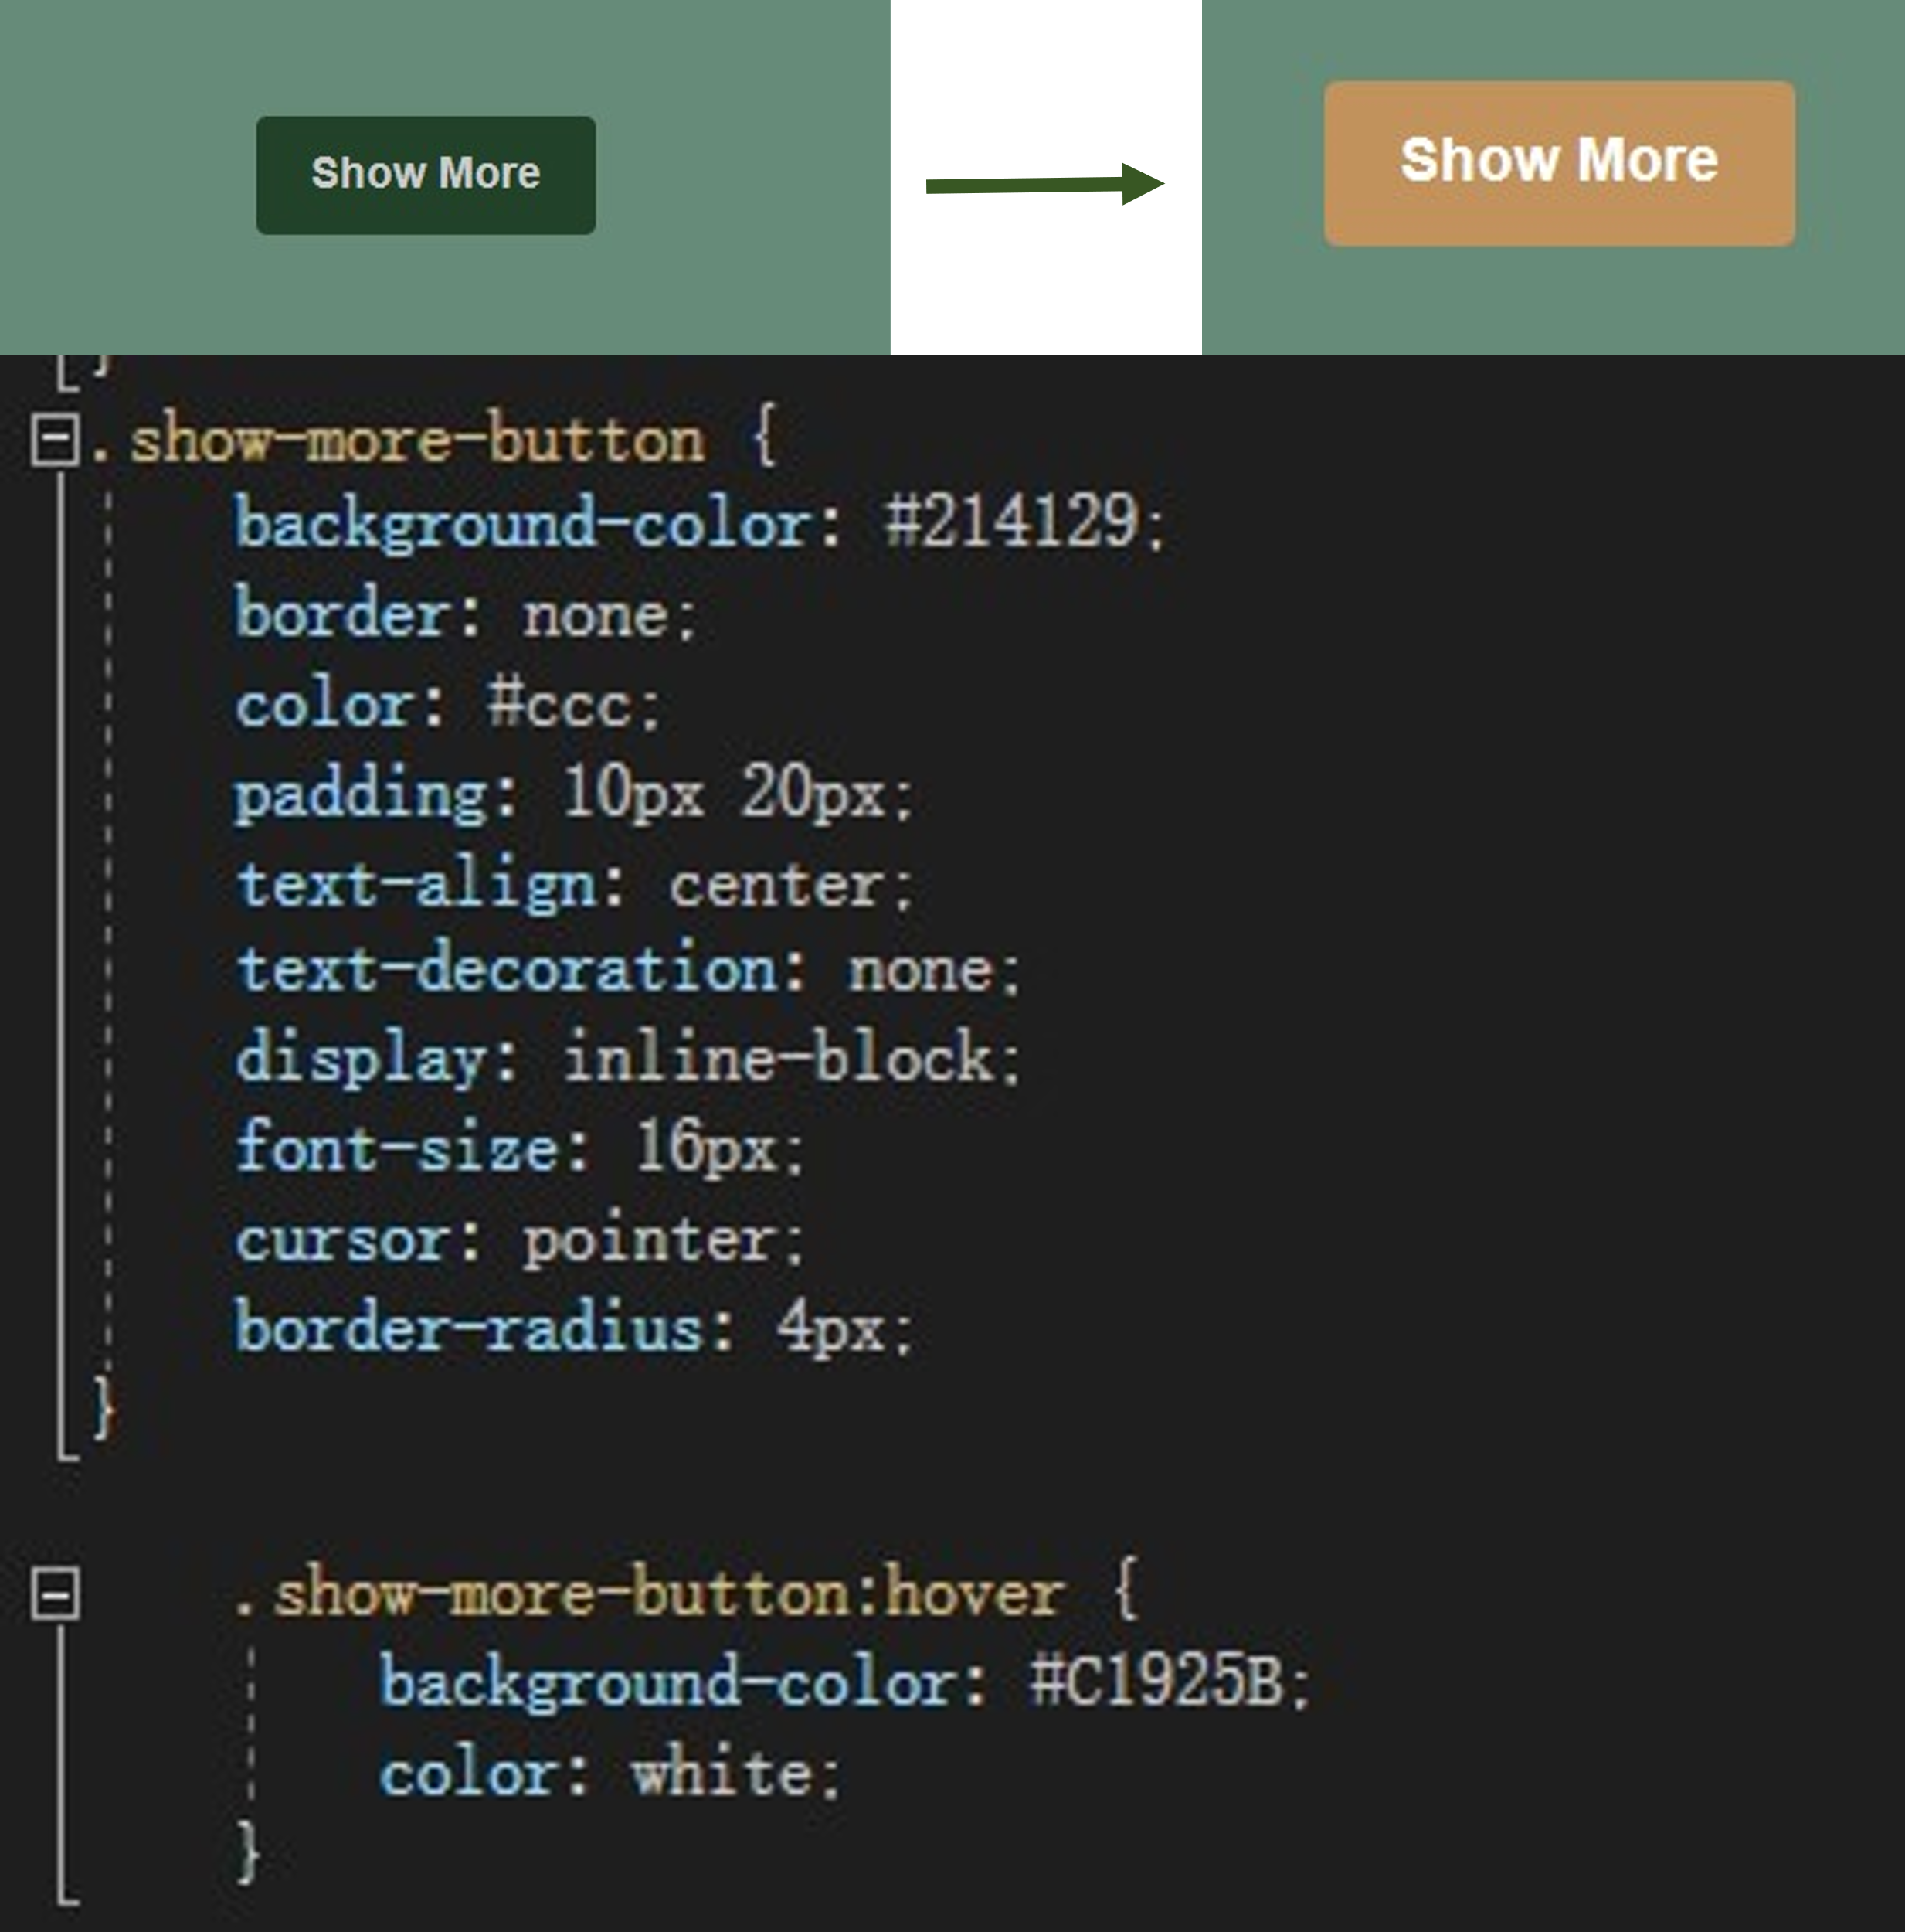

## JavaScript

### Mode frame

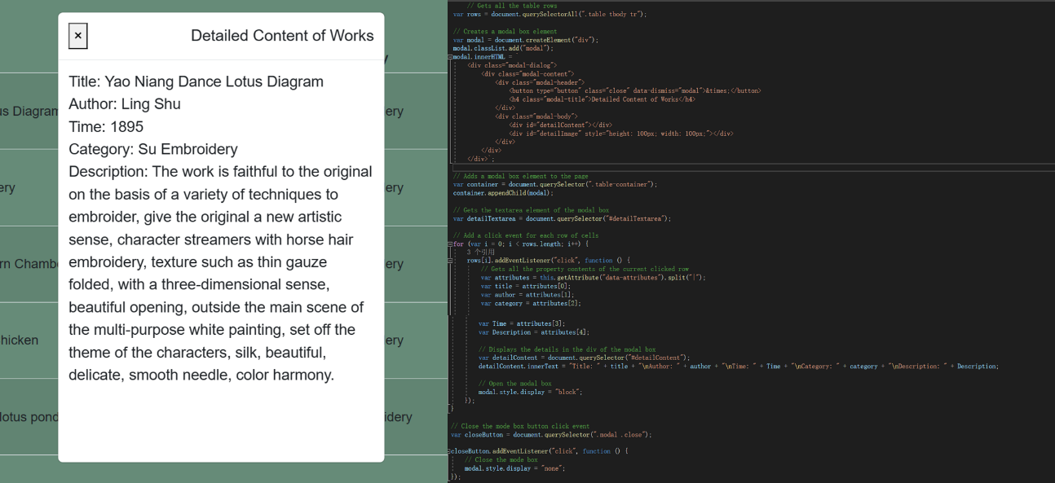

This code implements a basic modal box function. This code adds a modal box to the page and displays detailed information based on the properties of the clicked row each time a row in the table is clicked.

First, the code retrieves all the row elements in the table and stores them in the "rows" variable.

Next, the code creates a <div> element and adds a style class with "class" as "modal" to it. The <div> element contains the basic structure of a modal box, including the title, content, and close button.

The code then adds the created modal box element to the ".table-container" element of the page. This element is the container of the modal box into which the modal box will be inserted.

Next, the code gets the <textarea> element in the modal box that is used to display the details and stores it in the "detailTextarea" variable.

The code then adds a "click" event listener for each table row element. When you click on a row, the event listener gets the property contents of that row and displays them in the details area of the modal box. The modal box is displayed after the detailed information is displayed.

Finally, the code adds a "click" event listener for the close button in the modal box. When the close button is clicked, the listener hides the modal box so that it no longer appears on the page.

### Displaying History Cards

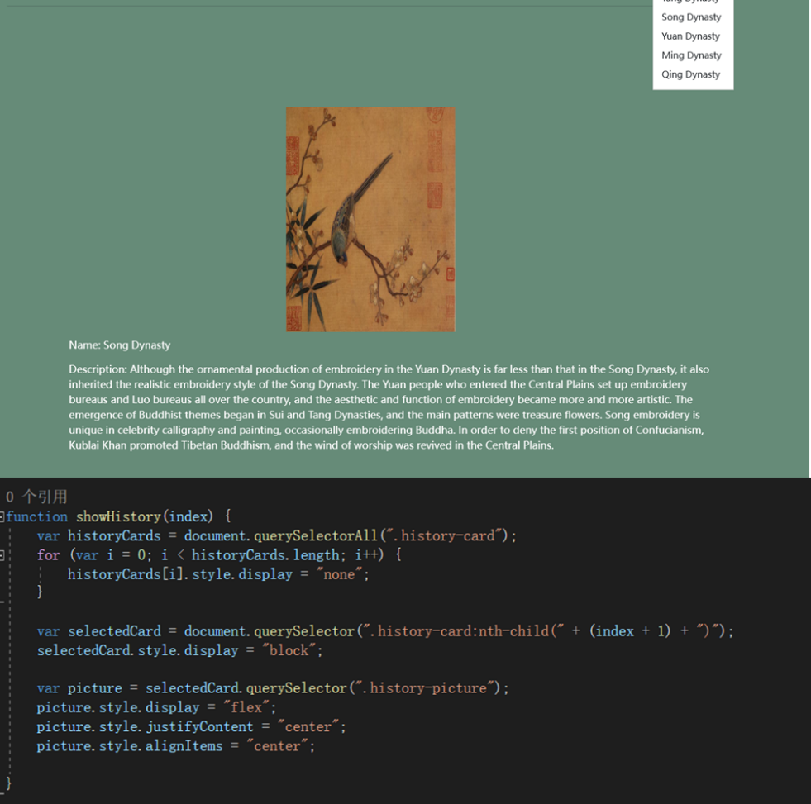

This code is a function that displays the embroider's corresponding history card. The function is called "showHistory" and takes an argument "index" to specify the index of the history card to be displayed.

First, the code takes all elements that have a "class" of "history-card" and stores them in the "historyCards" variable.

Then, use a loop to iterate through all the history card elements. On each loop, set the "display" style of the current history card elements to "none" to hide them.

Next, the code uses the selector ".history-card:nth-child(" + (index + 1) + ")" to find the history card to display. "index + 1" is used here to match the index value in the selector, because the index in the selector starts at 1, while the index in JavaScript starts at 0.

Then, set the "display" style of the selected history card to "block" to display it.

Next, the code takes the element in the selected history card that has "class" as "history-picture" and stores it in the "picture" variable.

Finally, the code applies some styles to the image container of the selected history card to center its contents. These styles include setting "display" to "flex" to enable flexible layout, and setting "justifyContent" and "alignItems" to "center" to center content horizontally and vertically, respectively.

### Click to appear text

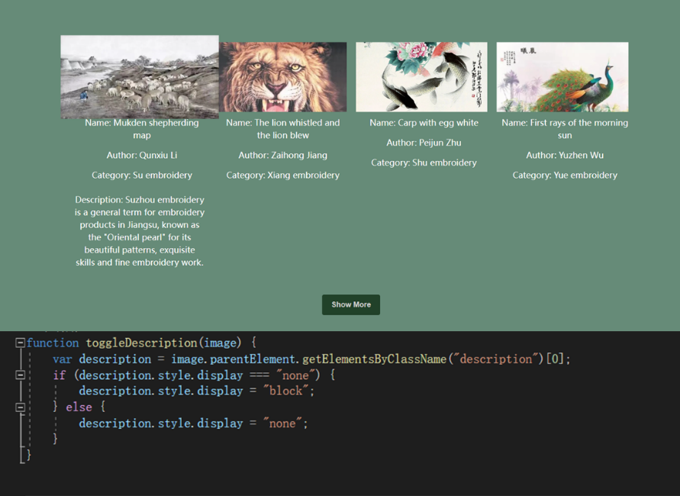

This code is a function that toggles the state of the description display. The function is to switch the display state of the picture by clicking on it. The function name is "toggleDescription" and it takes an argument "image", which represents an image element.

First, the code uses "image.parentelement" to get the parentElement of the image element, and then uses the "getElementsByClassName()" method to get the set of elements under the parent element with "class" as "description". Since this method returns a collection, we need to use "[0]" to get the first element in the collection and store it in the "description" variable.

Next, the code determines the current display state of the "description" element by determining its "display" style. If the style is "none", the description is currently hidden.

In the "if" conditional statement, if the description is hidden, the code sets the "display" style of the description to "block" to make it appear.

In the "else" statement, if the description is not hidden, the "display" style of the description is set to "none" to hide it.

### Verify css and html

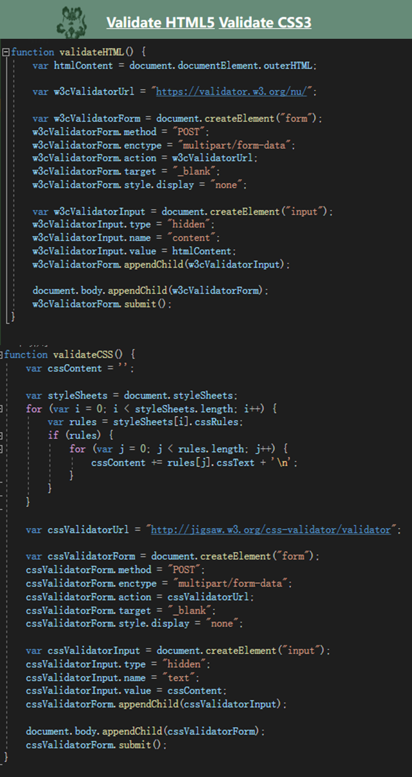

The function of this code is to provide the function of verifying HTML and CSS code, the user can click the link button, send the code to the corresponding validator for verification, and view the verification results in the new TAB. This can help find and correct errors and problems in HTML and CSS code to ensure the correctness and quality of the web page.

The validateHTML() function is used to verify the validity of HTML5 code. It first gets the contents of the entire HTML document and then sends the content to the W3C Validator API for validation. It creates a hidden form, takes the HTML content as part of the form data, then adds the form to the document and submits it to open the W3C Validator website in a new TAB and display the validation results.

The validateCSS() function is used to verify the validity of CSS3 code. It first takes the contents of all the stylesheets and stores the CSS text of all the rules in a variable. It then creates a hidden form with the CSS content as part of the form data, then adds the form to the document and submits it to open the CSS Validator website in a new TAB and display the verification results.

## Function realization

We implemented these functions in the Index in ProductsController.cs. Here is an example of a page that implements the functionality.

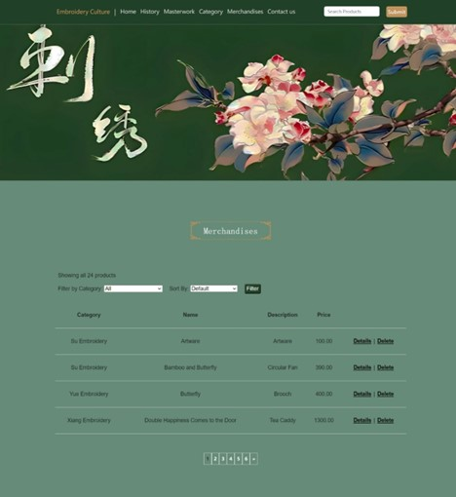

### Implementation of search function

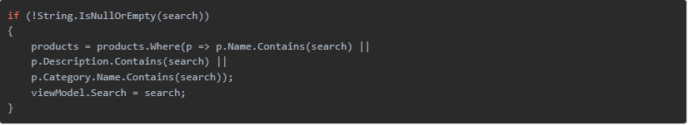

If a Search parameter is passed, use the Where method to filter out products that contain the search keyword in their name, description, or category, and save the search keyword in the search property of the viewmodel.

### Product Quantity Statistics by category

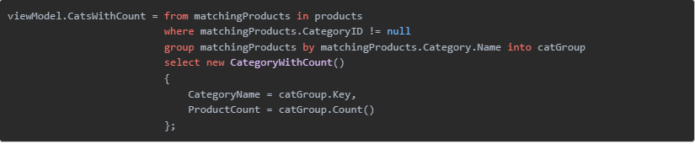

Using LINQ queries, the products are grouped and the number of products under each category is counted, and the results are stored in the CatsWithCount property of the viewmodel.

### Filtering products in a specific category

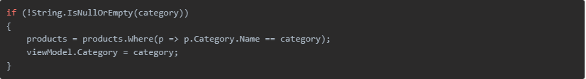

If a Category parameter is passed, filter out the products of the corresponding category using the Where method and update the category attribute of the viewmodel.

### Implementation of sorting function

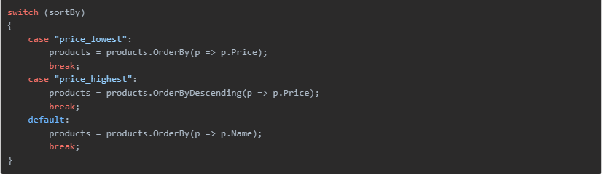

The query results are ordered using either the OrderBy or OrderByDescending method, according to the ordering parameters passed in, which can be ordered by low to high or high to low price, or by product name.

### Build sorting options

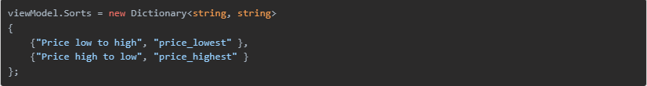

Creates a dictionary object that stores the sort name and corresponding sort parameters to generate sort options in the view.

### Implementing Paging



Defines the number of products to display per page, and defaults to page 1 if no page number parameter is passed in. The sorted query results are then paginated using the ToPagedList method and stored in the Products property of the viewmodel.

# Appendix

Here is the URL of my demo video:

https://www.bilibili.com/video/BV1YG41197bH/?spm_id_from=333.999.0.0